Fixing a broken system: a new idea for disability support

There are big difficulties with support for disabled people.

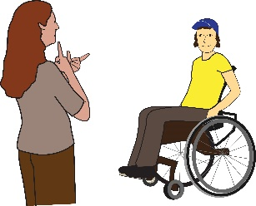
This is the case with support both for physical needs and mental health needs.

The support that there is for Disabled people now has links back to the way that disabled people were treated many years ago.

Many years ago, Disabled people were locked up in big hospitals for their whole lives. They were kept apart from their families and they could not live in the community.

The Second World War ended in 1945. After it ended there were some big changes in Britain.

One of these changes was to set up a “welfare state”.

Having a “welfare state” means that:

- School is free for all children

- Healthcare is free for everyone. This means it is free for people to see a doctor or go to hospital.

- Adults who are out of work get money to live on.

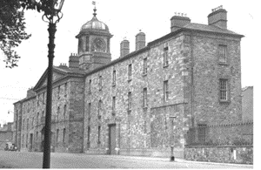

When the “welfare state” was set up in Britain nothing changed for disabled people. They were still locked away.

The big long stay hospitals they were locked in were run by local Councils.
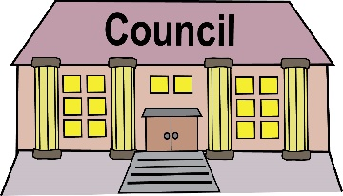

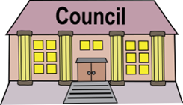

Today, local Councils still run services for Disabled people.

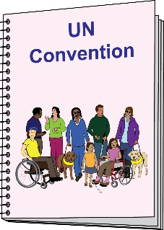

Too often these services do not respect the human rights of Disabled people.

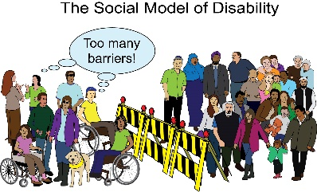

Too often these services do not fit with the social model of disability.

What we need is a whole different way of supporting Disabled people.

Part 1. Why we need change
Things are in a Mess

Not enough funding
There is not nearly enough funding for disability support services.

More and more people need support and services cannot give support to all the people who need it.

Services are becoming unsafe.

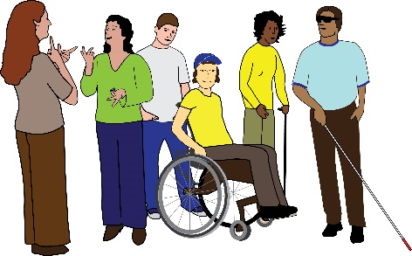
There are some groups of Deaf and Disabled people who are not able to get support.

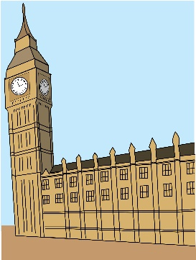

The Government is not doing enough

Things the Government has done do not go far enough.

Government plans to raise more money for social
care will not be enough to fix all the problems.

Most of the money that is raised will go into health not social care.
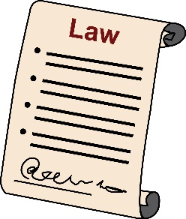
There is a new law on mental health. It does not go far enough to protect the human rights of disabled people.

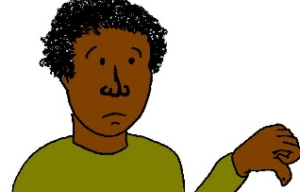
It does not work having local Councils in charge of disability support services
The way disability services are run now is not joined up.

Disabled people get different services depending on where they live.
Some services are run for profit. This means that people who own the services take money that could be spent on making the services better.
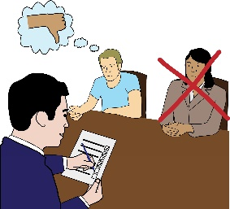

Local Councils put a lot of time and effort into turning Disabled people down for support.

They do this to try and save money.

Local Councils have become more and more worried about funding since 2010.

Services run by local Councils work differently to the NHS:

- The NHS is free whatever medical needs you have.

- Councils only have to provide support for disabled people that fit within the funding they have. If disabled people’s needs cost more money than the Council has, then they don’t have to meet those needs.
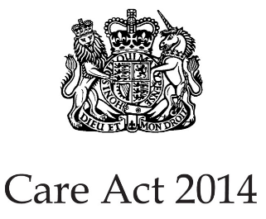

This was true before and after the Care Act 2014 came in.

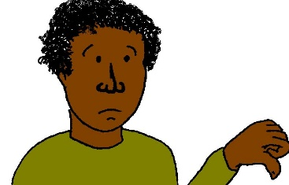
Until this changes, services will carry on treating Disabled people badly.

!

We need change quickly

Without change, abuse will carry on and Disabled people will die when they don’t need to.
More and more disabled people are becoming disabled.

Society does care about disabled people, even if they don’t fully understand it.

Sorting out disability support services will make things better for society.

Part 2. TO TALK ABOUT: A New Idea

Most people think something needs to be done about social care.

A lot of reports have been written on this.

There has been lots of talking about it.

Nearly all of this looks at how to find more money to spend on social care.

It does not look at how to make big changes to the way services are run.

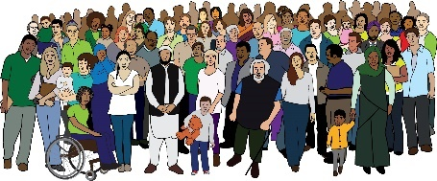
Disabled people who use services, organisations run by Deaf and Disabled people and campaign groups all got together to come up with a big new idea.

Our new idea is for a National Independent Living Service. This service would be in charge of support for disabled people.

It would cover the whole country.

It would be in line with disabled people’s human rights.

It would provide support that fits round disabled people’s whole lives.

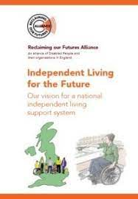
This new idea was set out in a paper called: “Independent Living for the Future: Our Vision for a National Independent Living Support System”.

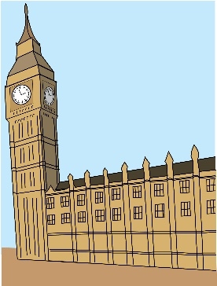
The paper was launched in Parliament on 25 April 2019.

Since then, support for our idea has grown.

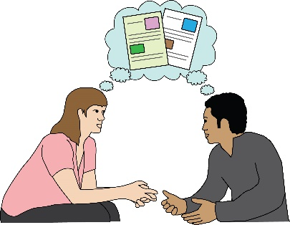

Now we want to start a conversation about what a National Independent Living service would look like in more detail.

Co-production

Any plans for the future of disability support must be drawn up with disabled people and our organisations.

Building on what we know works

Drawing up plans for our new idea does not need to start from scratch.

There are examples of things that have worked in the past.
These include:

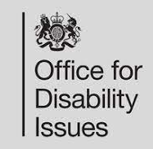
Disabled Peoples User Led Organisations (DPULO) Programme
The Government ran this programme from 2005 – 2015.
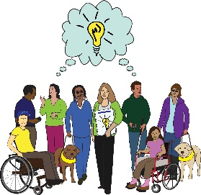
It was a programme to help set up more organisations run and controlled by Deaf and Disabled people across the country.

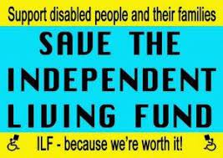
Independent Living Fund
This funded support for disabled people with high support needs to live in the community.
People who used the service were very happy with it.
It cost a lot less to run than Council run services.

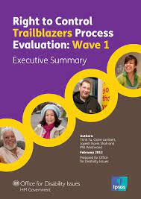
Right to Control Trailblazer Pilots
The idea of Right to Control was to bring together different bits of support that disabled people get into one.
The idea was that it would:
- save the disabled person time
- give them more control over the support we use
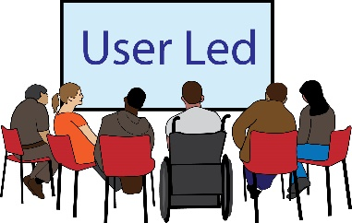
Disabled people and our organisations were fully involved in coming up with and testing out the ideas behind Right to Control.
It was shut down after the Coalition government came to power in 2010.
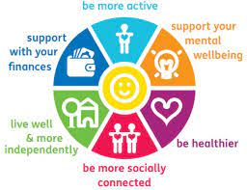
Social Prescribing
Social Prescribing is a service that Disabled people can get now.
It is run by NHS England.
It links up Disabled people with support to stop them feeling so alone and to help them be part of their community.
A National Independent Living Support Service

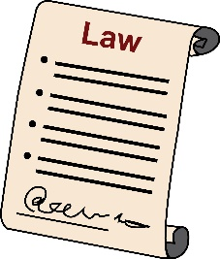
The idea:
A right to independent living for all Disabled people in law
A new service that is drawn up and run by Disabled people working with government and with workers
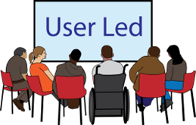
A service that is funded through taxes
A service that is free for all

What it will look like
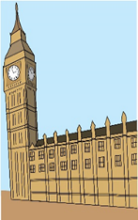
- It will be national.
- The Government will have to report to Parliament on it.
- Disabled people who use support services will be involved in running the new service.
- The new service will work with local Councils and with Deaf and Disabled People’s Organisations.
- These partnerships will make sure there is a range of good services available to Deaf and Disabled people in every local area.

?
QUESTIONS TO TALK ABOUT

- What different types of support do we need for disabled people?
And which of these will be run by:
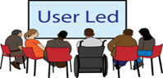
Deaf and Disabled People’s Organisations?
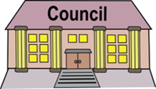
Local Councils?
?
Other local organisations?

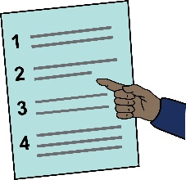
- What jobs would a National Independent Living Service do?

- How can we make sure that disability support is free for everyone to use?

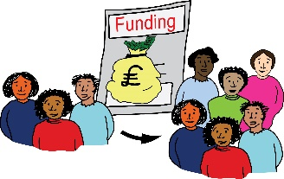
- How can we make sure that disability support services have enough staff to run properly?

