Great News – Heidi Crowter’s Court case is being heard in full
What is happening at the Court of Appeal?
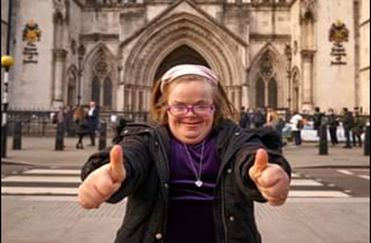
The Court of Appeal judges will be hearing why Heidi is saying that the Abortion law that promotes disability discrimination affects how society treats disabled people. The Abortion law that allows disabled and non-disabled unborn babies to be treated unequally gives the message that disabled people can be treated unfairly and unjustly. Disabled people should be treated the same as non-disabled people at all times, this is a human right.

Please note that the Court of Appeal will not be dealing with how unborn disabled babies themselves are treated unfairly in the Abortion Law.
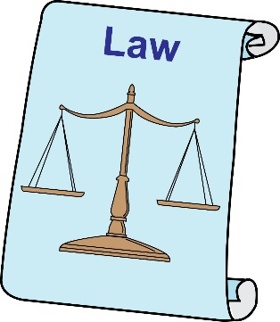
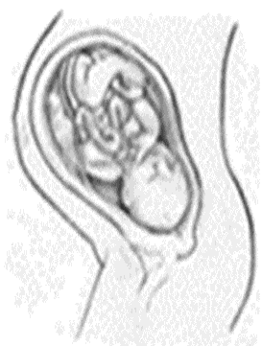
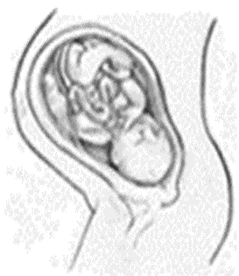

Disabled

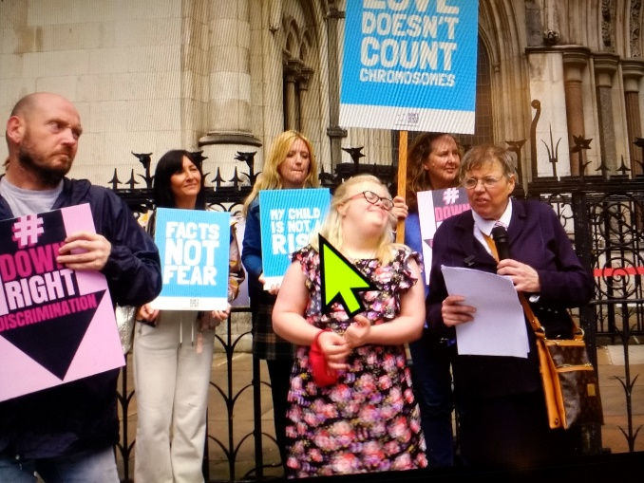
We want the judges to see that Heidi’s court case is being supported by lots and lots of disabled people. So it’s really important that we are at the Court of Appeal itself, being seen by Heidi and the judges who will decide whether the Abortion Law goes against disabled people’s human rights to be treated fairly and free from disability-related discrimination.
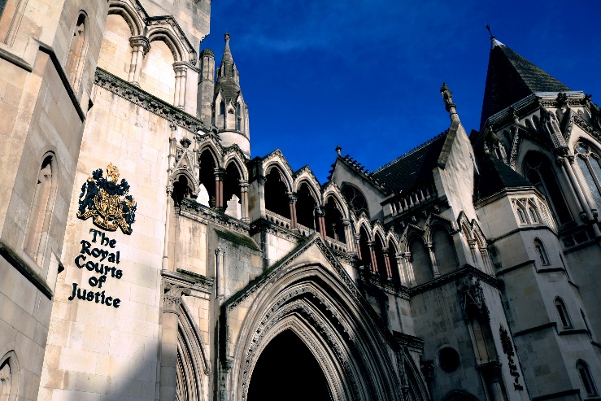
Heidi’s court case
Address
Royal Courts of Justice
Strand,
London WC2A 2LL

Date of court hearing: Wednesday, 13th July 2022

Times
Time: from 9.00 am if you can

Court hearing is 10:30 am

Court hearing to end 4.30 pm

We want Heidi’s court case to be accessible for all disabled people including those with learning difficulties
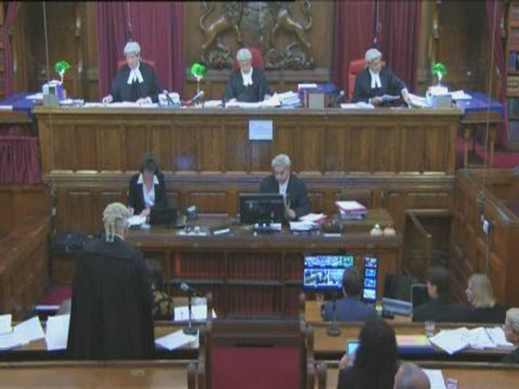
Attend the Court of Appeal hearing itself
We need judges to see that Heidi is supported so please do come anytime between 9.00 am to 4.30 pm. Feel free to stay as long as you like in or outside the High Court.
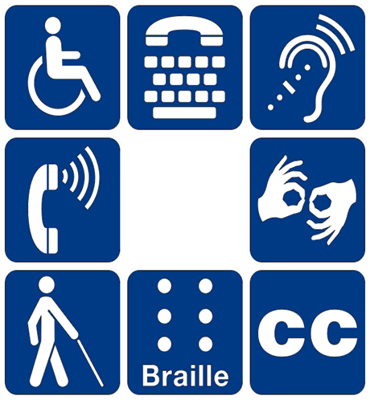
An accessible Court Hearing
ROFA is expecting that the National Court Service will continue to be very helpful after the last hearing which took place on March 8th where the staff agreed to:
- A wheelchair accessible high court room
- Live streaming of the court hearing
- The public gallery is open so that we can all sit in the court hearing.
- An agreement to consider easy read information and judgement of Heidi’s court case
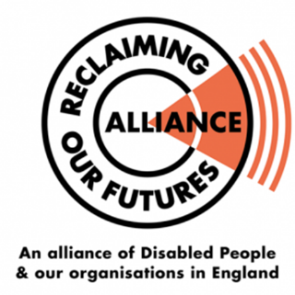
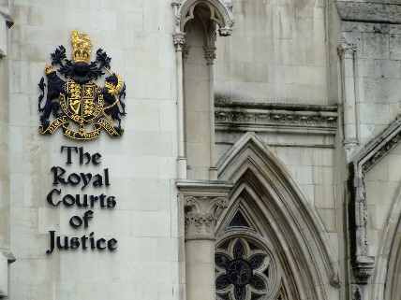
Whilst ROFA is in contact with the court service – it would be helpful for disabled people to make requests for any help you need to make the court hearing more accessible for all.
Things to think about are:
Accessible court room and toilets
Help with getting to the court itself
Support with hearing the court case (hearing loop)
British Sign Language or any other communication support
Information about the court case in a different formats
Easy-read information about what is going on in the court hearing including understanding what the lawyers and judges are saying or anything else
Sample email you can write to
ross.kitley2@justice.gov.uk
civilappeals.listing@justice.gov.uk
Simone Aspis’s PA Sedley simone.pers.ass@gmail.com
Dear Ross and Sally
I am a disabled person who will be attending Heidi Crowter’s Court of the Appeal hearing on 13th July. Please can you do the following so I have equal rights to access and understand Heidi court case hearing under Equality Act 2010?
Write what is needed make Heidi court case accessible for disabled supporters.
Please let me know that you are going to make the court hearing accessible for me and other disabled people. Looking forward to a fully accessible court hearing – which will benefit all disabled people.
Yours sincerely Your name and organisation
Need more information or finding it hard to access Heidi’s court case contact
020 7947 6190
RNID Typetalk 020
18001 (Text) 18002 (Voice)
(Helplines for the deaf and hard of hearing)
www.civilappeals.gov.uk

Heidi Crowter’s Court of Appeal Oral hearing is being lived stream
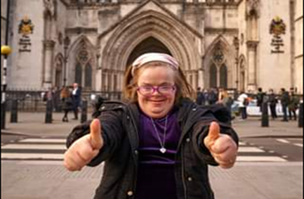
Supporters will be able to listen to the Court of Appeal hearing from the following website:
https://www.judiciary.uk/you-and-the-judiciary/going-to-court/court-of-appeal-home/the-court-of-appeal-civil-division-live-streaming-of-court-hearings/.
The video will also be accessible from this website after the hearing.
Expenses
If we raise enough money, we will be able to think about paying disabled people expenses for coming to the court hearing.

We have started a fund-raising page - to raise money for disabled supporters who would like to attend and support Heidi’s court case. If you can please give some money to help cover disabled peoples costs
Click: https://tinyurl.com/5cptt25n

If you need any information about the court case.
Simone Aspis’s PA Sedley simone.pers.ass@gmail.com

