If you are new to and need some background information about Heidi’s court case. Follow: https://www.rofa.org.uk/wp-content/uploads/2021/11/heidi-judgement-withpicturesNOV2021.docx

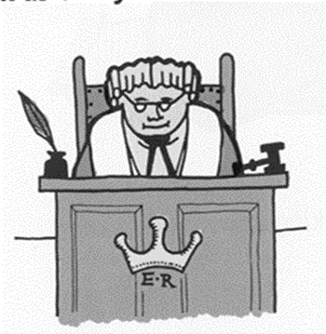
The Court of the Appeal hearing
What are the court judges being asked to make decisions about in Heidi’s court case?

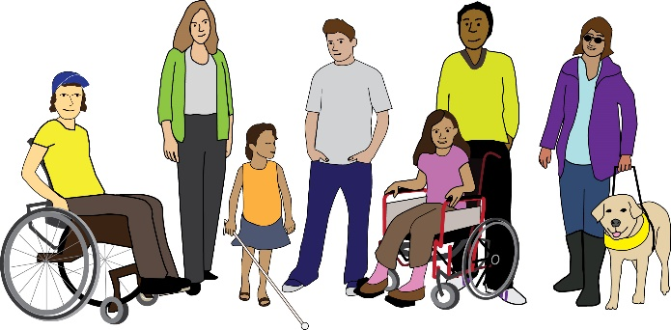

The Court of Appeal judges will only review and decide if the Abortion law which allows disabled unborn babies to be aborted up to birth, leads to negative attitudes towards disabled people or the value of their lives on the following grounds:
ECHR Article 8 – the right to respect for private life and family life.
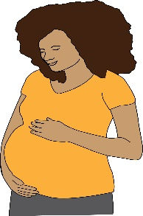
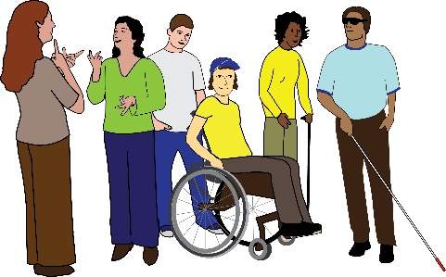
- Does the Abortion Act breach Art 8 ECHR, and should the protection of Art 8 ECHR extend in such a way that the Abortion Act should consider the rights of both pregnant women and Disabled people?

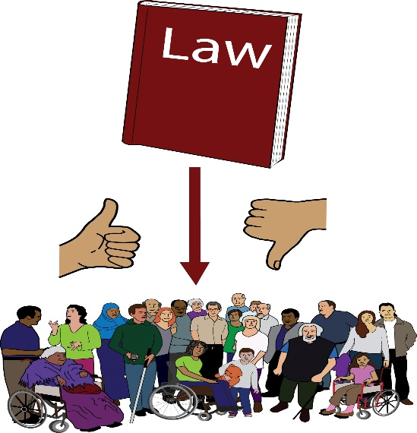
- Whether the High Court judgement was wrong in making the decision that the Abortion Act does not support negative / bad attitudes and does not maintain stereotypes to the harm of disabled people or the value of their lives?

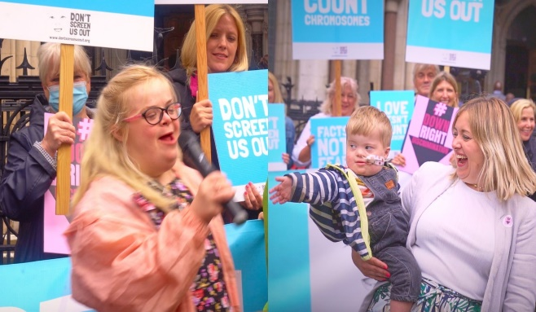
- Whether the High Court judges should have looked favourably in extending the protection of Art 8 ECHR to support disabled people, and in particular Heidi and Aidan’s human rights?

- Whether it is justified to interfere with pregnant women and disabled peoples human rights on the basis that it is in accordance with the law.
Substantial risk

This means that when doctors rely on terms in the Abortion Act such as “substantial risk” and “seriously handicapped” to guide their disability-related abortion decisions, the court will consider whether these terms so broad and vague that they are inconsistent with Art 8 ECHR?
Seriously handicapped

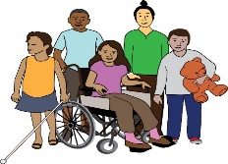
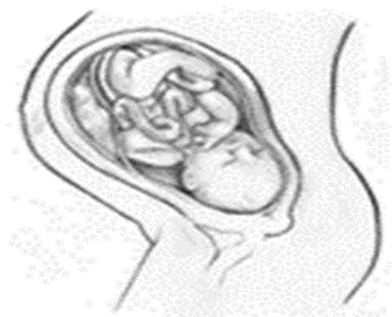
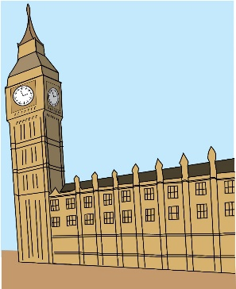
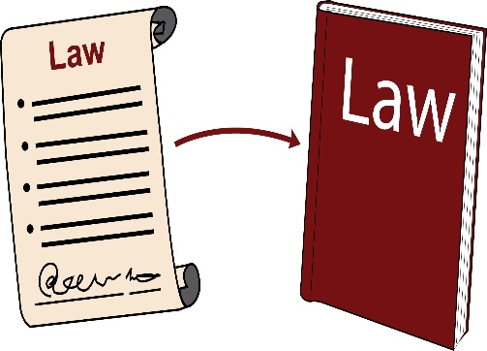
Disabled

- Has the correct balance been struck between the Abortion law limiting disability-related abortions and the rights of disabled people, and does this fall within Parliament’s power over making their own laws?
ECHR Article 14 – Right to be treated equally
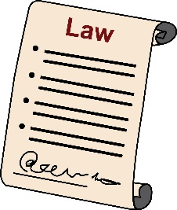
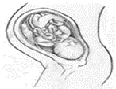
Does the different treatment of non-disabled and disabled unborn babies under the Abortion law give rise to disabled peoples being treated unequally?
Disabled

By Simone Aspis Changing Perspectives

