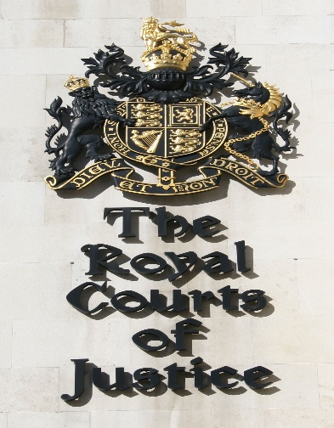
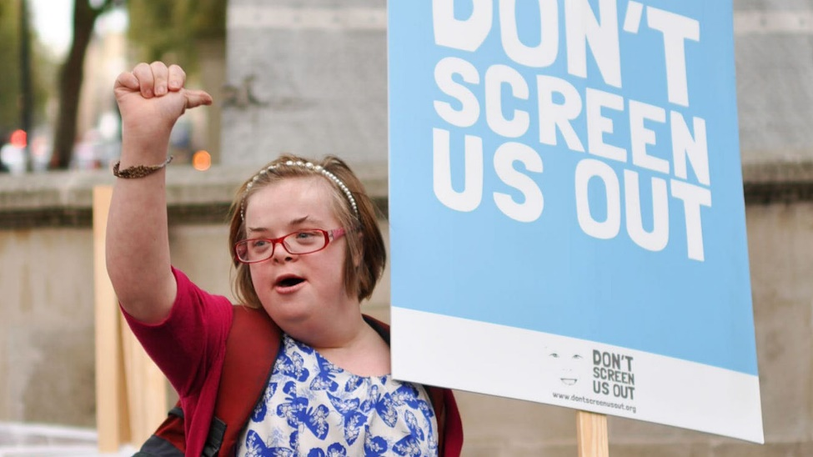
#Downrightdiscrimination #Equally Valued

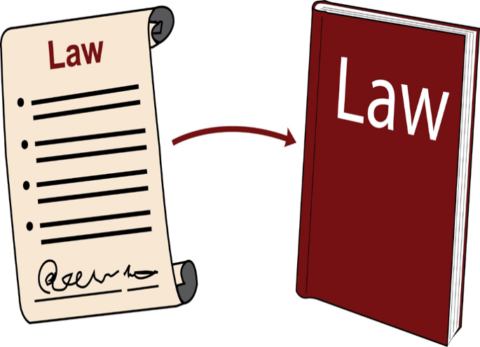
Heidi Crowter’s Court of Appeal hearing - 13th July
She wants the law changed to give disabled and non-disabled babies equal right to life.
The Abortion Act is the law around pregnant women’s rights to stop the birth of the baby.
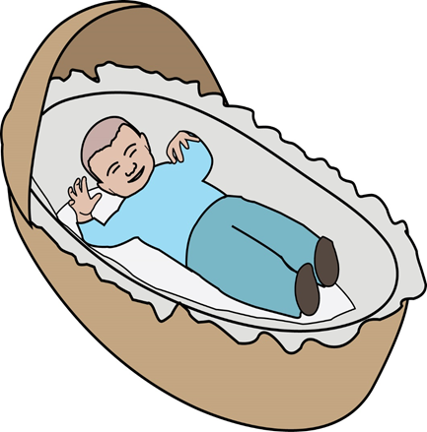
Disabled

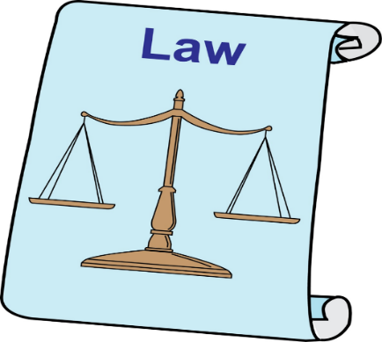
What does the law say?
The Abortion Act is the law around pregnant women’s rights to stop the birth of a baby.
The law says
Pregnant Women must have a very good medical reason such as their life is in danger to stop giving birth to a non-disabled baby after 24 weeks old.
Pregnant Women can stop the birth of a severely disabled baby up to 36+ weeks without any reason.
Disabled people have reported that the Abortion law allows disabled people being treated badly and in a discriminative manner before and after birth and throughout their lives.

Pregnant Women must have a very good medical reason such as their life is in danger to stop giving birth to a non-disabled baby after 24 weeks old.
Pregnant Women can stop the birth of a severely disabled baby up to 36+ weeks without any reason.
Disabled people have reported that the Abortion law allows disabled people being treated badly and in a discriminative manner before and after birth and throughout their lives.

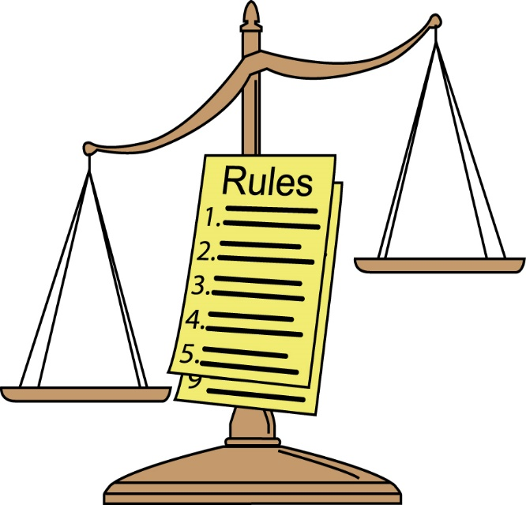

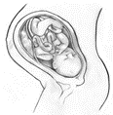
Disabled
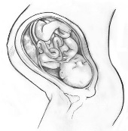

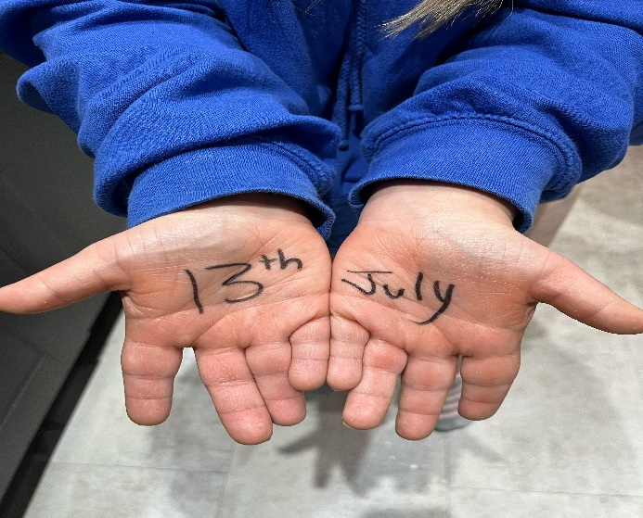
The Abortion law is allowing disability discrimination and unfair treatment of disabled unborn babies. The Abortion law must be changed to stop society’s negative attitudes towards disabled people lives.

#HoldHandsforEquality #EqualInsideOut

