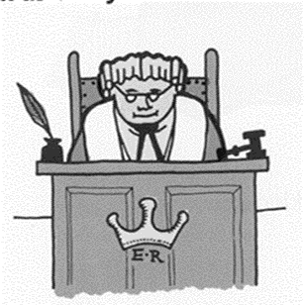
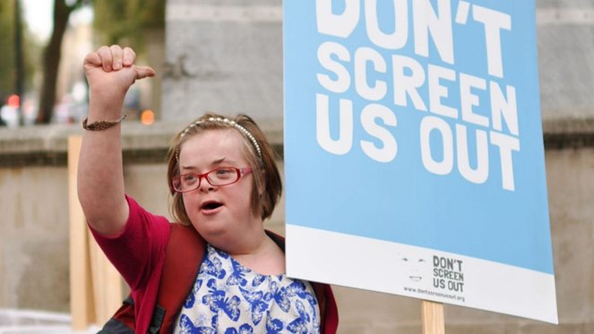
Great News – Heidi Crowter’s Court Case is now being considered by the Court of Appeal.
What is happening at the Court of Appeal?
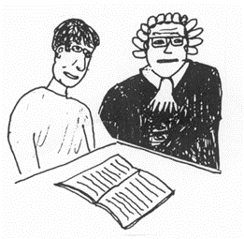
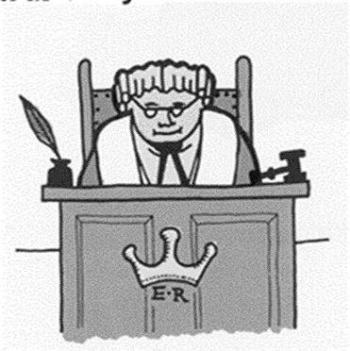

The Court of Appeal have agreed to meet Heidi and her legal team for about two hours. The Court of Appeal judges want to hear why the law needs to be changed so that disabled and non-disabled unborn babies are treated equally under the Abortion law.
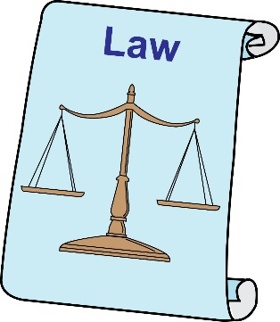
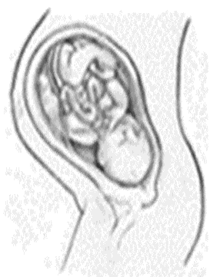
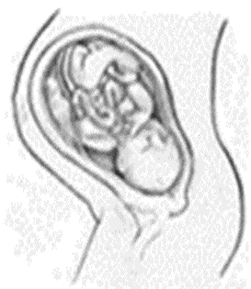

Disabled

We want the judges to see that Heidi’s court case is being supported by lots and lots of disabled people. So it’s really important that we are at the High Court itself, being seen by Heidi and the judges who will decide that the case goes to the Court of Appeal for a full hearing.
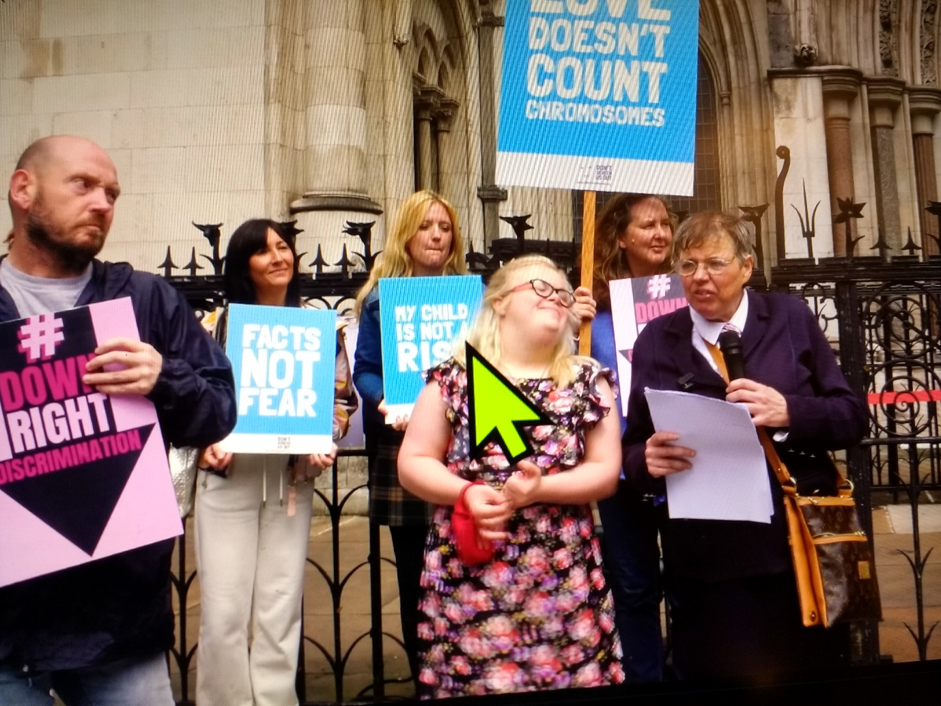
Want to know more about Heidi’s court case visit https://www.rofa.org.uk/heidi-high-court-case-september-2021/
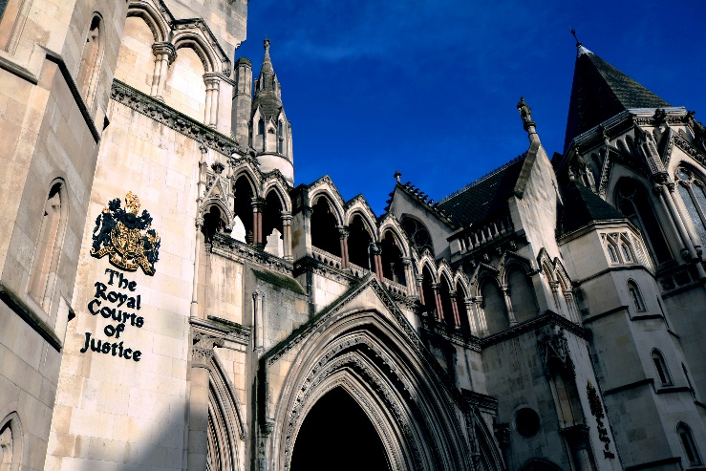
Address
Royal Courts of Justice
Strand,
London WC2A 2LL

Date of court hearing: Tuesday, 8th March 2022

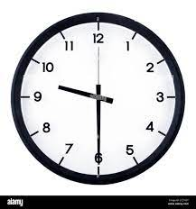
Time : from 9.30 am if you can

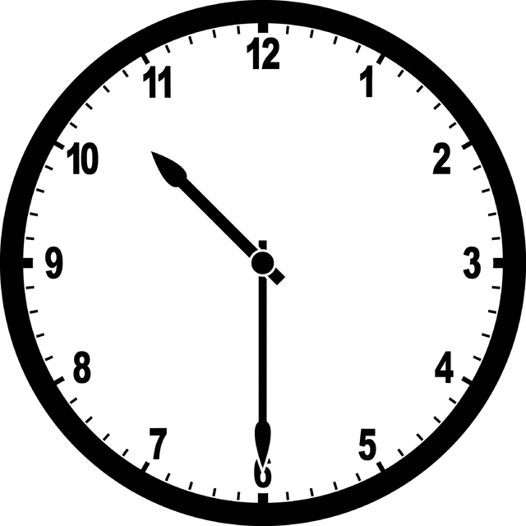
Court hearing is 10:30 am

More information to follow.
Contact simone@changingperspectives.org.uk

Mobile Number is 07464-797-453

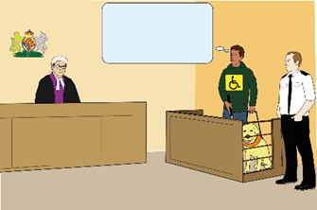
court room number 74

Court room number 74 (3rd Floor of the East Block) – wheelchair accessible court room
There will be seats for supporters in the Public Gallery

Heidi Cowter’s Court of Appeal Oral hearing is being lived stream
Supporters will be able to listen to the Court of Appeal hearing from the following website:
https://www.judiciary.uk/you-and-the-judiciary/going-to-court/court-of-appeal-home/the-court-of-appeal-civil-division-live-streaming-of-court-hearings/.
The video will also be accessible from this website after the hearing.
Need more information or finding it hard to access Heidi’s court case contact
020 7947 6190
RNID Typetalk 020
18001 (Text) 18002 (Voice)
(Helplines for the deaf and hard of hearing)
www.civilappeals.gov.uk

