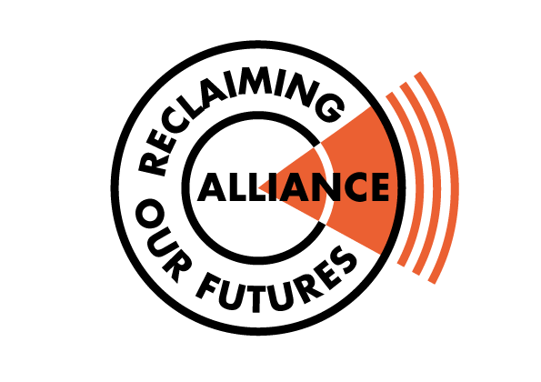

Reclaiming Our Futures Alliance Press Statement read out by Simone Aspis
Reclaiming Our Futures Alliance (ROFA) are delighted that the Judges have granted permission for the Court of Appeal to hear Heidi Crowter’s Abortion Act 1967 court case. For too long the Abortion Act has been left without being challenged on equality and human rights grounds. The Abortion Act 1967 not only affects people with Downs Syndrome but disabled people as a whole and women wanting to bring up disabled children in this world. This court case is simply about removing the disability discrimination clause that allows severely disabled foetuses to be aborted up to birth and ensuring the woman’s rights to abortion is retained on the same grounds for all. All legislation that allows disability discrimination must be challenged as it affects how disabled people are valued and perceived by society at large including women wanting to have children free from prejudice.
Heidi and ROFA is supported by both international disabled and women’s human rights monitoring committees who are not afraid to challenge the UK Government’s appalling record on upholding disabled peoples human rights.
Reclaiming Our Futures Alliance submitted evidence to the UNCRPD Monitoring Committee highlighting the negative impact that the UK Abortion law has had for both pregnant women and disabled people and that the law must change. The UNCRPD Monitoring agreed with ROFA.
The UNCRPD Monitoring Committee’s report told the UK Government: “The Committee is concerned about perceptions in society that stigmatize persons with disabilities as living a life of less value than that of others and about the termination of pregnancy at any stage on the basis of fetal impairment. The Committee recommends that the State party amend its abortion law accordingly. Women’s rights to reproductive and sexual autonomy should be respected without legalizing selective abortion on the ground of fetal deficiency.”
For more information about ROFA’s support for Heidi’s court case visit Heidi High Court Case September 2021 - (rofa.org.uk)
Simone Aspis Mobile Number : 07464-797-453
Email address simone@changingperspectives.org.uk

