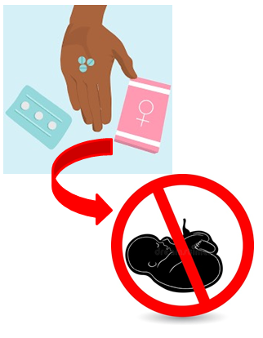
Heidi court judgement – Easy Read
Heidi went to court because she wanted abortion law changed so that it does not discriminate on grounds of disability. At the moment, it allows abortion at any time if the unborn baby is likely to have a serious disability, but abortion for other reasons can only happen before the mother is 24 weeks pregnant.
The easy read information can be found – include ROFA’s web-link

The court decided Heidi had lost her case.

The judge said that the Abortion Act 1967 does not interfere with any of the human rights of disabled people or disabled unborn babies. He didn’t agree with Heidi that it interfered with:
Disabled
Disabled
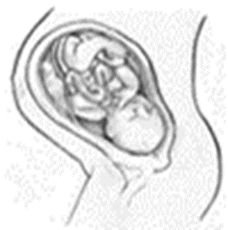

- the right to life (protected by Article 2 of the European Convention);
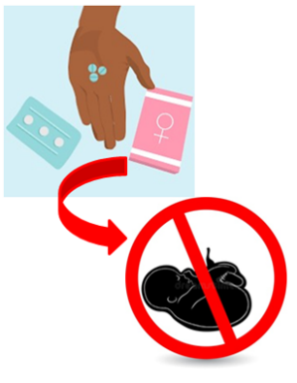
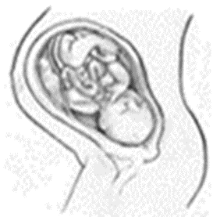

- the right to be free from inhuman and degrading treatment (protected by Article 3 of the European Convention);

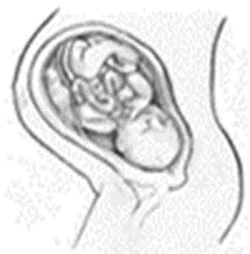
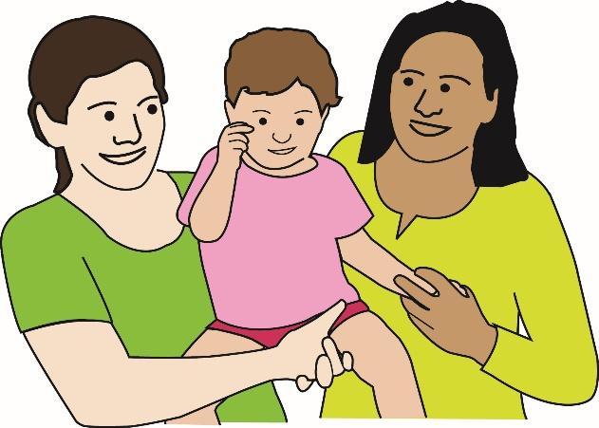
Disabled

- the right to private and family life (protected by Article 8 of the European Convention); or
Disabled

- the right to enjoy Convention rights free from discrimination (protected by Article 14 of the European Convention).
What the judge said about each of these rights is explained next.

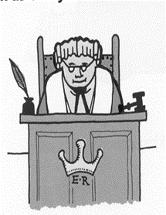
ECHR Article 2 Your Right to Life (page 8-9) weblink
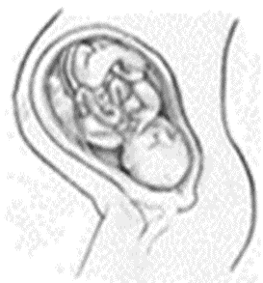
The judge said that you can’t normally have rights until you are born. So unborn disabled babies don’t have rights. So they don’t have the right to life under Article 2 of the European Convention on Human Rights (ECHR). The judge said that:
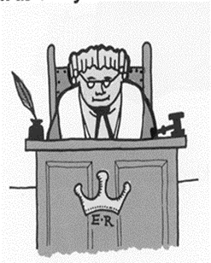
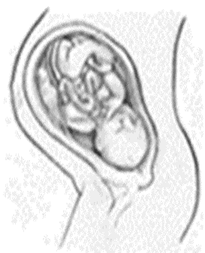
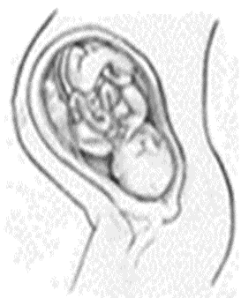
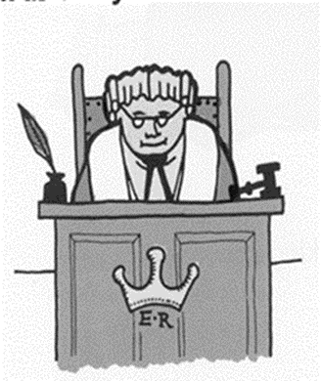

The UN Convention on the Rights of Persons with Disabilities (UN Convention) and the European Convention on Human Rights (European Convention) only cover people after they have been born. The international human rights agreements do not clearly cover unborn babies rights to life.
There have been no international court judgements saying that unborn babies have a right to life.
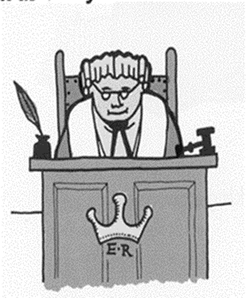
The European Court of Human Rights has always ruled that babies must be born before they have a human right to life.

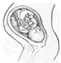
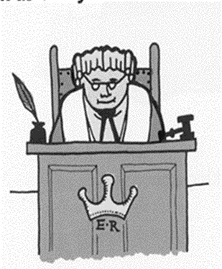
Disabled
The European Court of Human Rights has said it is for individual countries to make their own laws around unborn babies’ rights to life. The UK can decide to make whatever law they want about unborn babies. Parliament is allowed to do the following
- Give non-disabled unborn babies strong rights to life.
- Give disabled unborn babies weak rights to life.
The judges said it’s for Parliament (the MPs we vote for) not the courts to change the law to give disabled and non-disabled unborn babies rights to life.

European Convention Article 3 Your right not to be tortured or treated in an inhuman way (Page 9) Web-link to European Convention

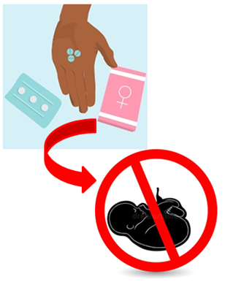

The judge said unborn babies have no human rights until they are born. There is no human right that stops them from suffering very bad treatment in the womb.
European Convention Article 8: Your right to Private and Family Life
Everyone has the right to respect for family and private life under Article 8 of the European Convention (pages 10-12) ECHR Article 8

The judge said a woman’s choice to become a parent or not to become a parent falls under this right. This means rules on abortion come under this right too.
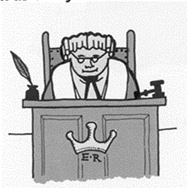
Disabled

The judge held that the UK Government could give good reasons for the rules on aborting unborn disabled babies in the Abortion Act. It had to balance the interests of pregnant women and the wider community, including disabled people.
The judge came to this decision because:
- Parliament has not given courts power to use international agreements (like the UN Convention) to change British law if it doesn’t protect disabled peoples’ rights.

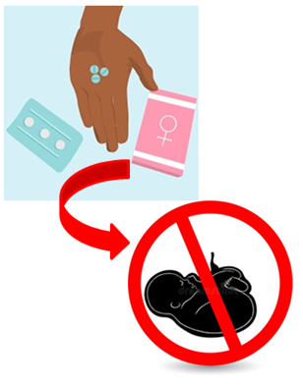

- The European Court of Human Rights has said each country has a choice about its own abortion rules.
- The Abortion Act means that abortions will not always be a crime. This means that the health and well-being of women can be taken into account. It can be cruel, and bad for a pregnant woman, to force her to give birth to a child she doesn’t want or feel she could look after.
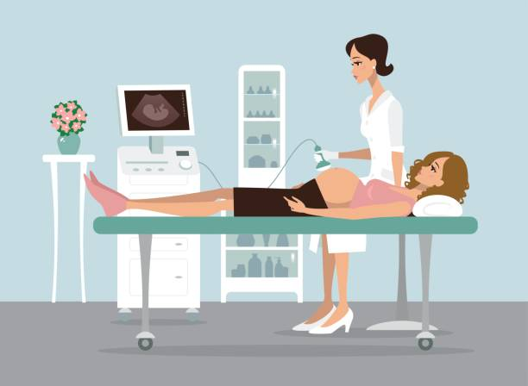
- Sometimes you can’t tell if a baby is going to be disabled until very late (after 24 weeks) in the pregnancy.

European Convention Article 14 Your right to enjoy your human rights without discrimination (Page 7)
The judges said that unborn babies do not have any human rights coming under Articles 2, 3 and 8. The judges said that because of this, Article 14 doesn’t help them. It can only be used if there is an interference with another European Convention right.
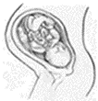

Disabled

The judge said unborn babies have no rights under the European Convention and that includes the right to not to be discriminated against. So the European Convention can’t be used to stop disabled and non-disabled unborn babies being treated unequally under the Abortion Act.
Unborn babies can face discrimination including disability-discrimination whilst in the womb.
The judge also said that there was no proof that the fact that the Abortion Act makes it easier to abort unborn disabled babies than non-disabled ones disadvantages living disabled people. He was not persuaded that the Abortion Act reinforced bad attitudes to disabled people or the value of their lives.

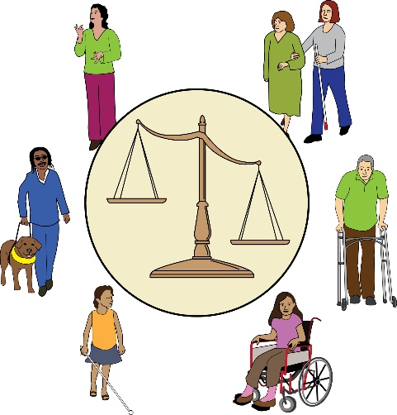
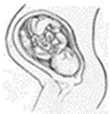
Disabled

The judge said that there was no conflict between the Equality Act, which makes it illegal to discriminate against living disabled people, and the Abortion Act, which discriminates against unborn babies who are likely to have severe disabilities.

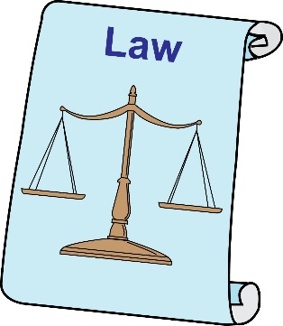
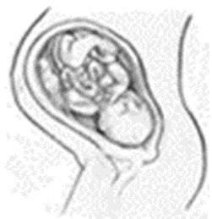
Disabled

By Simone Aspis
Changing Perspectives

