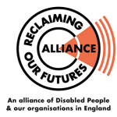 Independent Living Film Project

Calling all Deaf and Disabled People – tell us why Independent Living matters to you!

How to get involved? Easy – make a video on your phone and send it to us, we will do the rest.
What do I need to do? Answer the questions below on camera and then send your video to us at info@rofa.org.uk
How long does it need to be? Maximum length is 4 minutes – one minute per question – we want quality, not quantity!

Questions
- What’s your name, where do you live and why is independent living important to you
- Based on your experience what is the difference between social care and independent living
- Why do we need a legal right to independent living and a national independent living support service?
- What is your main message to the UK Government?

At the end of the video tell ROFA you give us permission to use your video for campaigning purposes to win a legal right to independent living and a national independent living service then send it to info@rofa.org.uk

