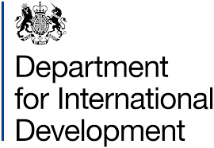
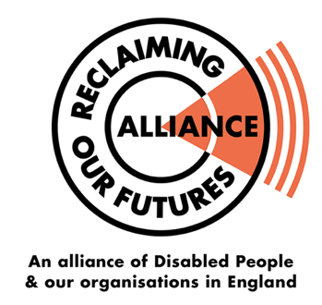

Conference on UK Disability and Development Cooperation for Disabled People and Representatives of Disabled People’s Organisations

Written by ROFA IC

Co-hosted by: DfID and ROFA IC
Funded by DfID

1st June 2019

#DisDevCoop2019
CONTENTS

Acknowledgement

Conference attendance list

About the conference

Part I - Conference

Feedback from Workshop

Part II: Conference UK DPO discussed how to get representation internationally

Recommendations

Appendix – Jargon buster

Appendix – Conference Agenda

- Acknowledgement

A big thank you to everyone that helped to make this Conference possible. Inclusion London for the back office and communications support. Independent Living Alternative for Personal Assistant support. British Sign Language interpreters and palantypists for ensuring communication needs where met. All ROFA and ROFA International Committee members. DfID for funding and co-hosting the Conference with ROFA IC.

We would like to thank the delegates for taking the time out of their weekend to attend the conference.

Thank you!

- Conference attendance list

DPOs
Action Disability Kensington & Chelsea
Alliance for Inclusive Education
Arts Organiser
Asian People's Disability Alliance (APDA)
British Deaf Association
Bromley Experts by Experience
Caribbean Disabled Sport Association CIC
Croydon Council
Disability Action Northern Ireland
Disability in Wales and Africa
Disability Labour
Disability Rep Forum
Disability Rights UK
Greater Manchester Coalition of Disabled People
Harrow Association of Disabled
Inclusion Barnet
Inclusion London
Latin American Disabled People's Project
Leeds Disabled People's Organisation
London Vision
More Than 1 Forum
National Survivor User Network
One Place East
National People First
REGARD
ROFA
Shaping Our lives
Transport for All
Unite the Union
Win Visable

Individuals
Ade Dada
Dr Terry Riley OBE
Elane Heffernon
Jazz Shaban
Sarah Gayton
Shamin Ali
Yemi Dada

DfID Staff
Penny Innes
Rachel Kean

ROFA International Committee (ROFA IC)
Anthony Ford
Iyiola Olafimhan
Mark Harrison
Michelle Daley
Rebeca Yeo
Richard Rieser
Tara Flood

- About the conference
On Saturday, 1st June 2019 over 50 Reclaiming Our Future Alliance (ROFA) members from across the UK, attended a Conference on UK Disability, International Development and Cooperation at Student Central, University of London Union, London.

The conference was co-hosted with the Department for International Development (DfID) and ROFA International Committee which involved DPOs from Wales and Northern Ireland.

The Conference was divided into two parts. Part one focused on providing feedback on DfID’s five year Disability Inclusion Strategy. While part two was a separate meeting for Disabled Peoples Organisations (DPO) and individuals to discuss and agree a way forward on international development issues.

This report has been written using information gathered from the speakers presentations and feedback from group discussions. The conference was a success and received positive feedback. Eighteen recommendations were identified which focused on helping to ensure good practice and supporting ROFA IC’s involvement in international development work. There was a diverse delegation of DPOs and individuals from across the country, in attendance. The majority of the delegates present were from diaspora backgrounds with an interest in international development issues. The Conference created the ideal platform for ROFA IC’s attendance at the Relaunch of the Commonwealth Disabled People Forum (CDPF) held at the Conference of State Parties (COSP) in New York.

A clear message came out of the conference that there must be co-production of UK DPOs within international development. There was also a consensus that UK DPOs must be supported to work in solidarity with Disabled sisters and brothers in areas of conflict, disaster, humanitarian work, research, training, etc.

Concerns were raised about the conference being a one-off event.

Some of the key questions posed were:
- How do UK DPOs get involved in international development?
- How to keep the momentum going?
- What is ROFA IC’s next steps?

The rest of this report will share the findings from the conference.

Part I – Conference
Feedback from Workshop

The following questions were posed by delegates and answered by Penny Innes on behalf of DfID.

Question: Why do we use 1 billion as the global prevalence?

(The most authoritative estimate of global prevalence is 1 billion from the 2011 World Disability Report).

Answer: This is likely to be a considerable under-estimate. Data quality is extremely poor in developing countries because of stigma and poor measurement. DfID is supporting governments to improve their measurement of disability which is an important part of our DfID’s new strategy.

Question: How many Disabled people are employed in government departments?

Answer: 14% of DfID staff have self-declared as having a ‘disability’. We aim to match the working age population of 19%. The average across all Government Departments is 9.9% (Source: ONS, Civil service statistics UK 2017). DfID has a relatively low proportion of staff declaring their disability status compared with other Government Departments which we are trying to improve.

- Feedback from Workshop

Questions:
- How can we work together to progress disability inclusive development?

- What have UK DPOs learnt from their experience of consultations that should be applied when engaging with DPOs in other countries?

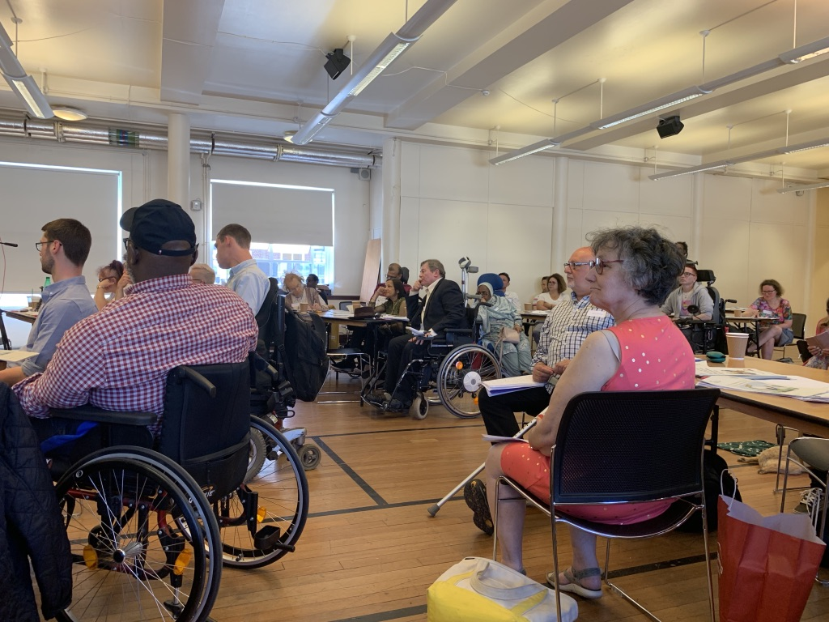

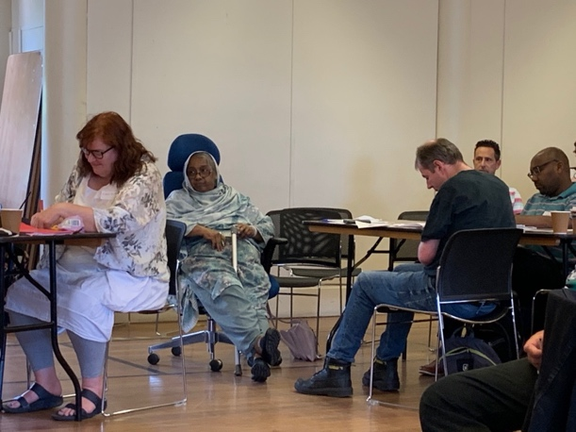
- Feedback
The following themes came out of the workshop discussions:
- Capacity building
- Inclusive Education
- United Nation Convention on the Rights of Persons with Disabilities (UN CRPD), Involvement and representation

- Capacity building
The following feedback highlights key discussions around capacity building:

Richard Rieser stated “Government strategy has a great deal to do with what our capacity is to do things around the world as DPOs.”

A key perspective on the topic of capacity building was that in order to achieve international initiatives, DPOs need to be properly involved in all areas of development (practice, policy, etc) and also given the opportunity to engage within shared learning.

There was a strong emphasis on the need for building capacity within UK DPOs as mentioned by one of the workshop groups.

One delegate stated “it strikes me that this conference is about building globally, you have to build at home to actually have a starting point.”

It was also stated by a delegate that there “needs to be a plan at home to actually give us [Disabled people] a starting point if it's going to be saying what needs to actually happen internationally. Because people are going to look at what's actually happening at home and say where's your credibility.”

Another comment was made by a delegate around technical skill gaps in areas such as organisation and administration which would have “real impact on the lives of Disabled people in the south.”

While another delegate stated, “we need a “strong user-led based model which means capacity building user-led Disabled people's organisations”

Also highlighted by delegates the need to think about the “humanitarian response to support Disabled people in the context of a humanitarian disaster or catastrophe. They further stated how important it is to train wider Disabled people which means thinking outside the box and involving the whole community, not just DPOs”

Richard Rieser provided further insight; “during the development of the UN CRPD there were plenty of DPOs that had the capacity and strength to actually run programmes.” The question was asked by a delegate “what has happened since”? Richard Rieser answered “The capacity for DPOs to function has been taken away and outsourced to non-DPOs like Leonard Cheshire international”.

One delegate put forward the view that the definition of Disability, Disabled people and impairment should be understood in line with the social model of disability. They said ”the understanding of promotion of that pride of being a disabled person and, you know, that barriers are external, causing them to be a disabled person, they're external, not internal” (Delegate).

The conclusion drawn was that there is a need for peer support, capacity building (technical and administrative) and funding for projects that are accessible and led by DPOs.

- Inclusive Education
Here is the feedback on discussions around Inclusive education:

Penny Innes made the following statement “…the aim is that every school has inclusive education actions in their plan and trained at least one teacher in every school [in Rwanda].” Inclusive education is one of the four areas of Disability Inclusion Strategy and we welcome that many countries in the global south are making positive progress within this area.

There were concerns on how inclusive education is being defined. It was noted that there are 65 million Disabled people and young people round the world who are not in any kind of education. Tara Flood stated that “this is a global disgrace”.

Tara Flood also provided the following insights:

“It's worth noting that the UK is one of only two countries in the world that placed both an interpretive comment and a reservation against Article 24 – Education which enable the UK to continue to segregate disabled children and young people and a reservation allowing the placement of disabled children far away from [their] home, where it is considered in the child's ‘best interest’”.

General Comment number 4 from the UNCRPD Committee which is a legally binding interpretation of Inclusive education.

However one delegate supported the UK reservation to have separate schools for Deaf children but this was not the consensus of the conference delegates as it contradicts the essence of Article 24.
One of the delegates expressed deep concerns that “due to their cultural reasons they [families] don't even send their children to proper schools to get the inclusive education or training.”

In summary the conference agreed that inclusive education means “an education system that welcomes and values all pupils and students, that everybody is supported, it's a bilingual education system that recognises and celebrates all pupils irrespective of background, ability and learning style equally, it supports every pupil and student, to reach a potential that that is self- defined” (Tara Flood).

- Involvement and representation
There was a lengthy discussion on the involvement and representation of DPO’s in international development. The following highlights key concerns and observations.

Mark Harrison provided an insightful perspective on the
“UN Convention [CRPD] in article 32 on international development it is very clear about the Government supporting international development. The UN Convention [CRPD] is very clear in Article 4 and 33, that it has to be with meaningful involvement of Disabled People's Organisations, in their own countries as well as in the south.”

UN CPRD was viewed as a critical mechanism for including all voices in decision making processes to bring about inclusion and human rights for all Disabled people globally. However, delegates at the conferences commented that “DPOs involvement were all tick box exercises.”

Further discussions were held which challenged interventions about the UK’s involvement with regressive Governments and other establishments. The following comments were made:
“Are we being asked to support a policy that excludes LGBT+ [people]” (Delegate).

“…I suggest that before we are campaigning for the schooling to be accessible, we need to think within that, whether privatisation is something that we want to be involved in, or whether in campaigning for that education to be accessible, we're actually giving credibility to something which is undermining people’s rights” (Rebecca Yeo).

Also key to this area of discussion was representation and addressing intersectionality inequality. For example it was noted from the Disability Inclusion Strategy that there are more Disabled men in employment than Disabled women which illustrates intersectional inequality. There are 20% of disabled women and 59% of disabled men are employed. In comparison 32% of non-disabled women are employed 71% of non-disabled men. The following questions arose from discussions around holding others accountable to address intersectionality inequality.

- Who is being represented?
- How is intersectional being addressed?
- What are mutually exclusive groups doing to address intersectional oppression?
- How are organisations being resourced and supported on intersectional issues?

One delegate shared the following experience
“I was at a meeting with people with hearing disabilities and visual disabilities and they raised their hands to say that they wanted to set up a social enterprise, but they weren't allowed to open a bank account. So, I was a bit shocked. Why can't you own a bank account? They said that the managers in the bank said that they cannot communicate with Deaf people and then the people with visual disabilities cannot read a bank statement, so they don't want to open the account.”
This is why it is important to ensure Nothing About Us Without Us!

There was a general consensus that there is a need for organisations to be held accountable to address stigma and discrimination concerning underrepresented Disabled people in areas such as:
- Gender inequality
- LGBTQI inequality
- Employment inequality
- Representation of people with learning difficulties

In summary, we need effective co-production as one delegate put forward the following suggestions “with UK DPOs, perhaps, as a consortium and preferably with participation from a diaspora of groups, we could go to Africa together, Asia or South America, wherever, as representatives who are there to ensure that things are, you know, advocated and implemented.”

- Conclusion
The workshop demonstrated that there is a need for UK DPO representation in development work with DPOs in the South and North. ROFA IC must ensure our work is sustainable, long lasting and UNCRPD focused which is why there needs to be solidarity. There is also a need for a systematic approach of communication between UK DPOs and DPOs in developing countries as well as the opportunity to share knowledge and lived experiences.

Part II - Conference

UK DPO discussed how to get representation internationally

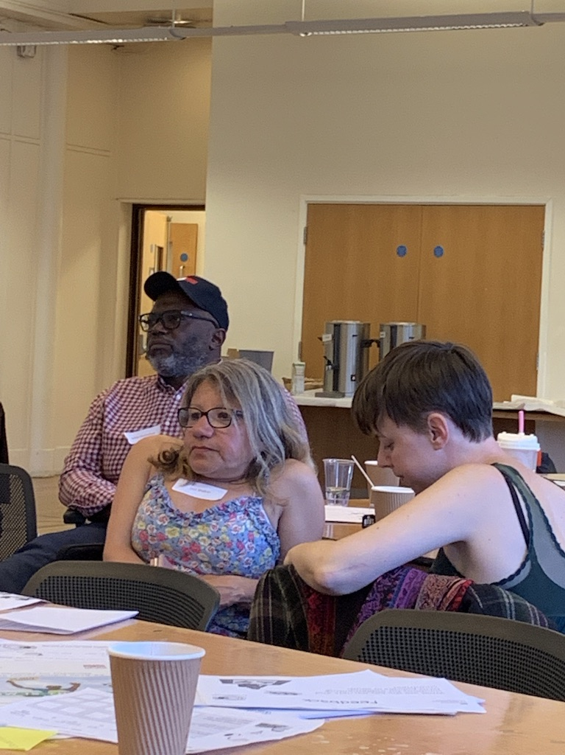

Feedback from group discussions

- How UK DPO’s should be represented internationally
Many of the points were mentioned in part 1 of this report. It was commented that ROFA IC should look at identifying a model for collaborative working between DPO’s and their Governments, for example Italy’s model which is project based. The overall aim will be to demonstrate fairness and involvement of DPOs in all areas of international work. These are the additional points that came out of the delegates discussion:

“get the new, young DPO groups involved as well so that their voices can really be heard and equally so they have full opportunities to be involved.”

“if we are going to feed-in and develop structure, particularly in the UK and you know, we can learn an awful lot from what has happened in the south in terms of what they're dealing with and ensuring that there is a voice for them. It is important that we don't create the same elite structures we did ten or fifteen years ago and perpetuate that as well.”

We “need to avoid having the same two people all the time and also, you know, people in groups that were mentioned here that are often invisible included within that.”

“having a disabled women's committee”

- Creating a DPO engagement structure?
While it was agreed that a structure is required, questions were raised around hierarchy, power dynamics and representation.

This is what some of the delegates had to say:

“ideally we would have some sort of structure where all the other DPOs can feed upwards in to that, so then everyone is still getting a say and their voice is being heard.”

“when you are looking at structures and certainly structures that we had in the past, you know, it speaks to the top tier of articulate Disabled people who have a voice and have gone to college and had access to education. What we want to develop is a proper structure that is representative of everybody, people on the bottom tiers.”

“we need to be democratic in elections for you know, for those that are representatives in groups and events.”

- Representatives to United Nations and Relaunch of Commonwealth Disabled People’s Forum (CDPF)
Conference participants welcomed the relaunch of the CDPF and the need for ROFA IC to send delegates to it. However, an observation was raised by a delegate that “in terms of venue, we need to think about the discrimination that may be happening in that country. For example, some people who have been Sectioned wouldn't actually be able to go to the States, that would rule them out.”

- UKDPO Representation at European Disability Forum (EDF)
It was agreed that there is a need for representation within the EDF because of the positive progress made regarding accessibility which will provide an opportunity for shared learning.

Richard Rieser noted that “all of the access things… have not come from British legislation, they come from European Directives.” But also “what the EDF asked for... at least they get some movement towards these things, so we need to be part of this whether we're in or out of Europe, after all they are our nearest countries.”

Here are some other comments made by delegates:
“When we had the disability forum for Europe, I was a part time consultant. It had its own women's committee and that fed into the European disabled women's committee. It functioned effectively as the only national disabled women's committee so it's just something to think about when we think about representative structure for international development. Do we want to recreate that? I believe the European women's committee is still going strong and leading on all the poll policy round women rather than the main committee; just something to think about.”

“I think [the] point round LGBT won't get out across the world but could… get it into Europe.”

- Recommendations from the ROFA International Committee
The report sought information from the conference to help make recommendations as to how the ROFA International Committee (ROFA IC) progresses in its work.

- Definition of Disability, Disabled people and impairment should be understood in line with the social model of disability.

- ROFA IC to represent UK DPOs internationally.

- ROFA IC to ensure diverse representation and encourage the involvement of people from underrepresented groups within its work.

- ROFA IC to increase the involvement of young Disabled people within its work.

- DPOs must lead on international development programmes and on the implementation of the UN CRPD otherwise Disabled people globally will not achieve human rights.

- ROFA IC to campaign to ensure any programme implemented is sustainable, long lasting and adequately resourced.

- ROFA IC to campaign for support to help ensure a systematic approach on communication between UK DPOs and DPOs in developing countries and provide an opportunity to share knowledge and lived experiences.

- Openness and accountability to restore working relationship between UK DPOs and DfID. The overall aim will be to demonstrate fairness and co-production of DPOs in all areas of international work.

- ROFA IC and DfID to co-host a follow up conference in Autumn 2019.

- ROFA IC to create and implement strategies for addressing intersectional inequality practiced internally and externally.

- ROFA IC not to support or engage in work that would give credibility but also undermine Disabled people’s rights.

- ROFA IC should refuse the involvement of or support given to regressive Governments / practices that do not support and/or promote equality and human rights of all people.

- ROFA IC to seek funding to create training development programmes to and for capacity building UK DPO’s to deliver on research, humanitarian, conflict and other areas of international development work.

- ROFA IC to continue to campaign for implementation of the UN CRPD Articles and General Comments, the co-production of DPOs in supporting international development in their own countries as well as globally.

- ROFA IC to continue to support the relaunch and development of the Commonwealth Disabled People’s Forum, its development and capacity building.

- ROFA IC to campaign for full implementation of UN CRPD Article 24 (Education) and to support good practices on inclusive education globally.

- ROFA IC to hold international non-governmental organisations (INGO) and Development agencies accountable around their duty to involve DPOs and / or complying with domestic and international instruments.

- ROFA IC to identify a good model for collaborative working between DPOs and their Governments, for example the Italian model.

Appendix – Jargon buster

Jargon Buster

- Disabled Peoples Organisation (DPO) refers to organisations that are run and control by Disabled people.

- International non-governmental organisations (INGO) aims and priorities is on international development.

- Intersectionality is the overlap of a person’s different identities resulting oppression and discrimination.

- Italian model refers to developmental processes based on developing and managing projects and engaging different professional skills to help resource and implementation.

- Lesbian, Gay, Bisexual, Transgender, Queer, Intersex (LGBTQI) refers to a person gender identity.

- United Nation Convention on the Rights of Persons with Disabilities (UNCRPD) is an international law focusing on Disabled people human rights.

Appendix – Conference Agenda

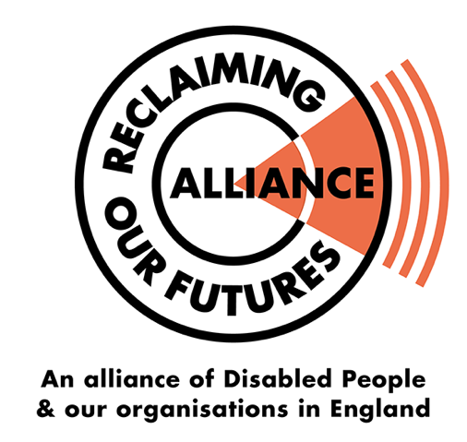
Meeting of UK Disabled Peoples Organisations to talk about how we work internationally

Funded by

When: Saturday 1st June 2019 Time:10.30am – 4.30 pm
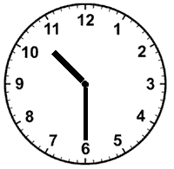

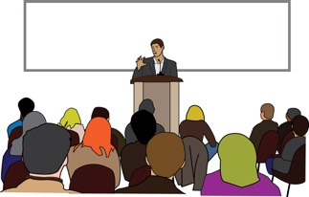
Where: Student Central, Malet Street, London, WC1E 7HU

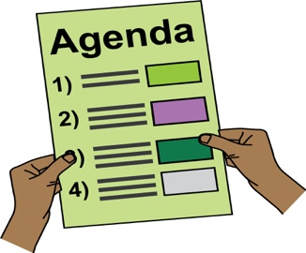
AGENDA

10:30 - 11.00 | Registration and Tea and Coffee
11.00 - 11.15  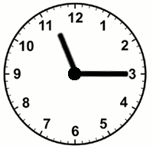  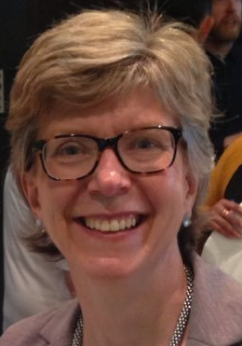  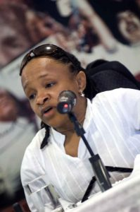  Michelle Penny  Daley Innes (ROFA IC) (DfID) | Welcome  Michelle Daley (ROFAIC) & Penny Innes (DFID) will welcome everyone.  - Go through the agenda for the day.  - Explain why the meeting is happening and what we want to achieve by the end of the meeting.  - Everyone in the room will have a chance to say who they are and what organisation they represent.
11.15 – 11.40 | Department For International Development (DfID) Presentation  - The presentation will talk about how the government developed their disability inclusion strategy for international development.  - The presentation will also talk about the work the UK government does in other countries to support disability inclusion.  An easy read version of the strategy is available here.
11.40 - 12.10 | Reclaiming Our Futures Alliance members share their views on DfID’s strategy and disability inclusion  - How UK Disabled people’s organisations can work with Disabled people’s organisations in other countries?  - What ideas are important?  - What are the difficult issues to work with in disability inclusion?
12.10 – 1.00  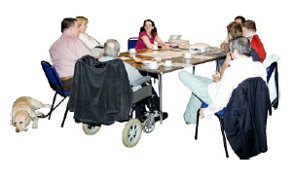 | Small Group discussions  In small groups, you will be asked to share ideas on how Disabled peoples organisations in different countries can work together more.  - What are the barriers and solutions to achieving disability inclusion across the world?
1.00 - 1.45  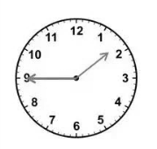 | Lunch
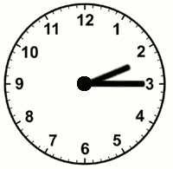  1.45 – 2.15 | Feedback, Questions and Discussion  - Each group will share some of what they talked about before the lunch break.  - There will be an opportunity to ask questions.
2.15 – 2.45  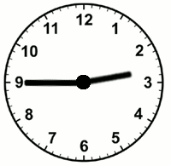  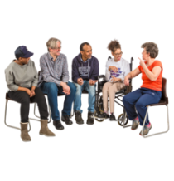 | Big Group Discussion  As one whole group, we will talk about how UK DPOs can support DfID to achieve their disability inclusion goals.
2.45 - 3.00  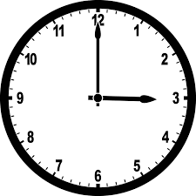  Michelle Penny Daley Innes (ROFA IC) (DfID) | Summary and what next  Michelle Daley and Penny Innes close the discussions and talk about what is going to happen next.
3.00 - 3.15 | Break  (Government staff leave)
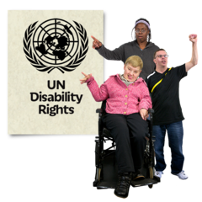  3.15 - 4.15  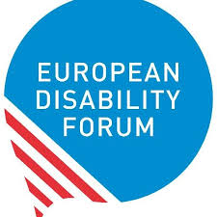 | Group discussion  Talking about how UK Disabled peoples organisations want to be represented internationally. In different places like:  - The United Nations  - The Commonwealth Disabled People’s Forum  - The European Disability Forum
4.15 – 4.30  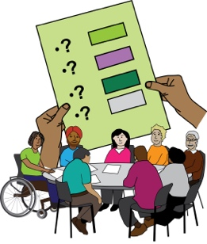 | Any other business (AOB)  Where people can raise issues or share information that has not been talked about during the day so far.
4.30  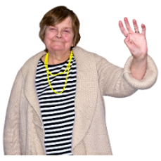 | Close and goodbye

