National Disabled People’s Summit – Meeting for Deaf and Disabled People on Saturday 4th November 2017.

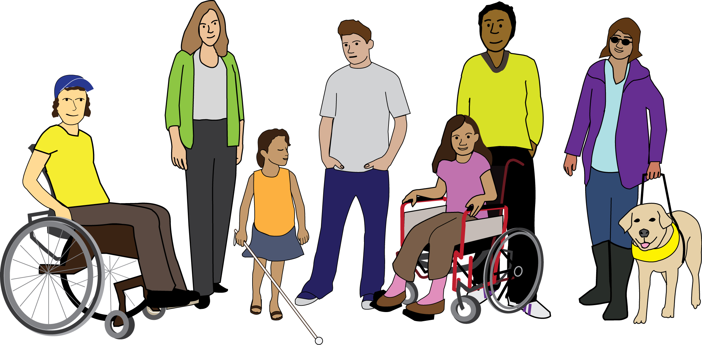
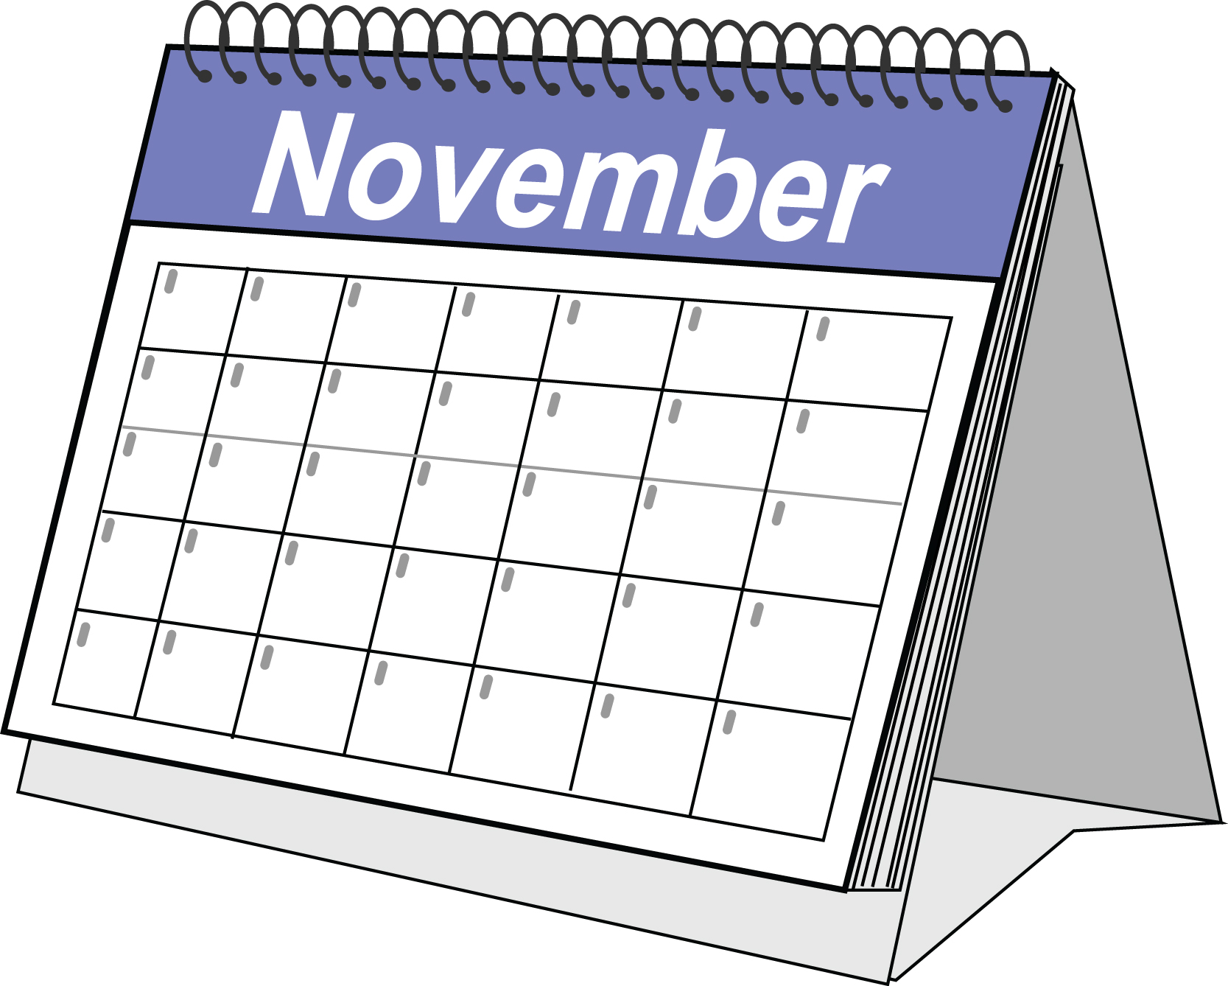

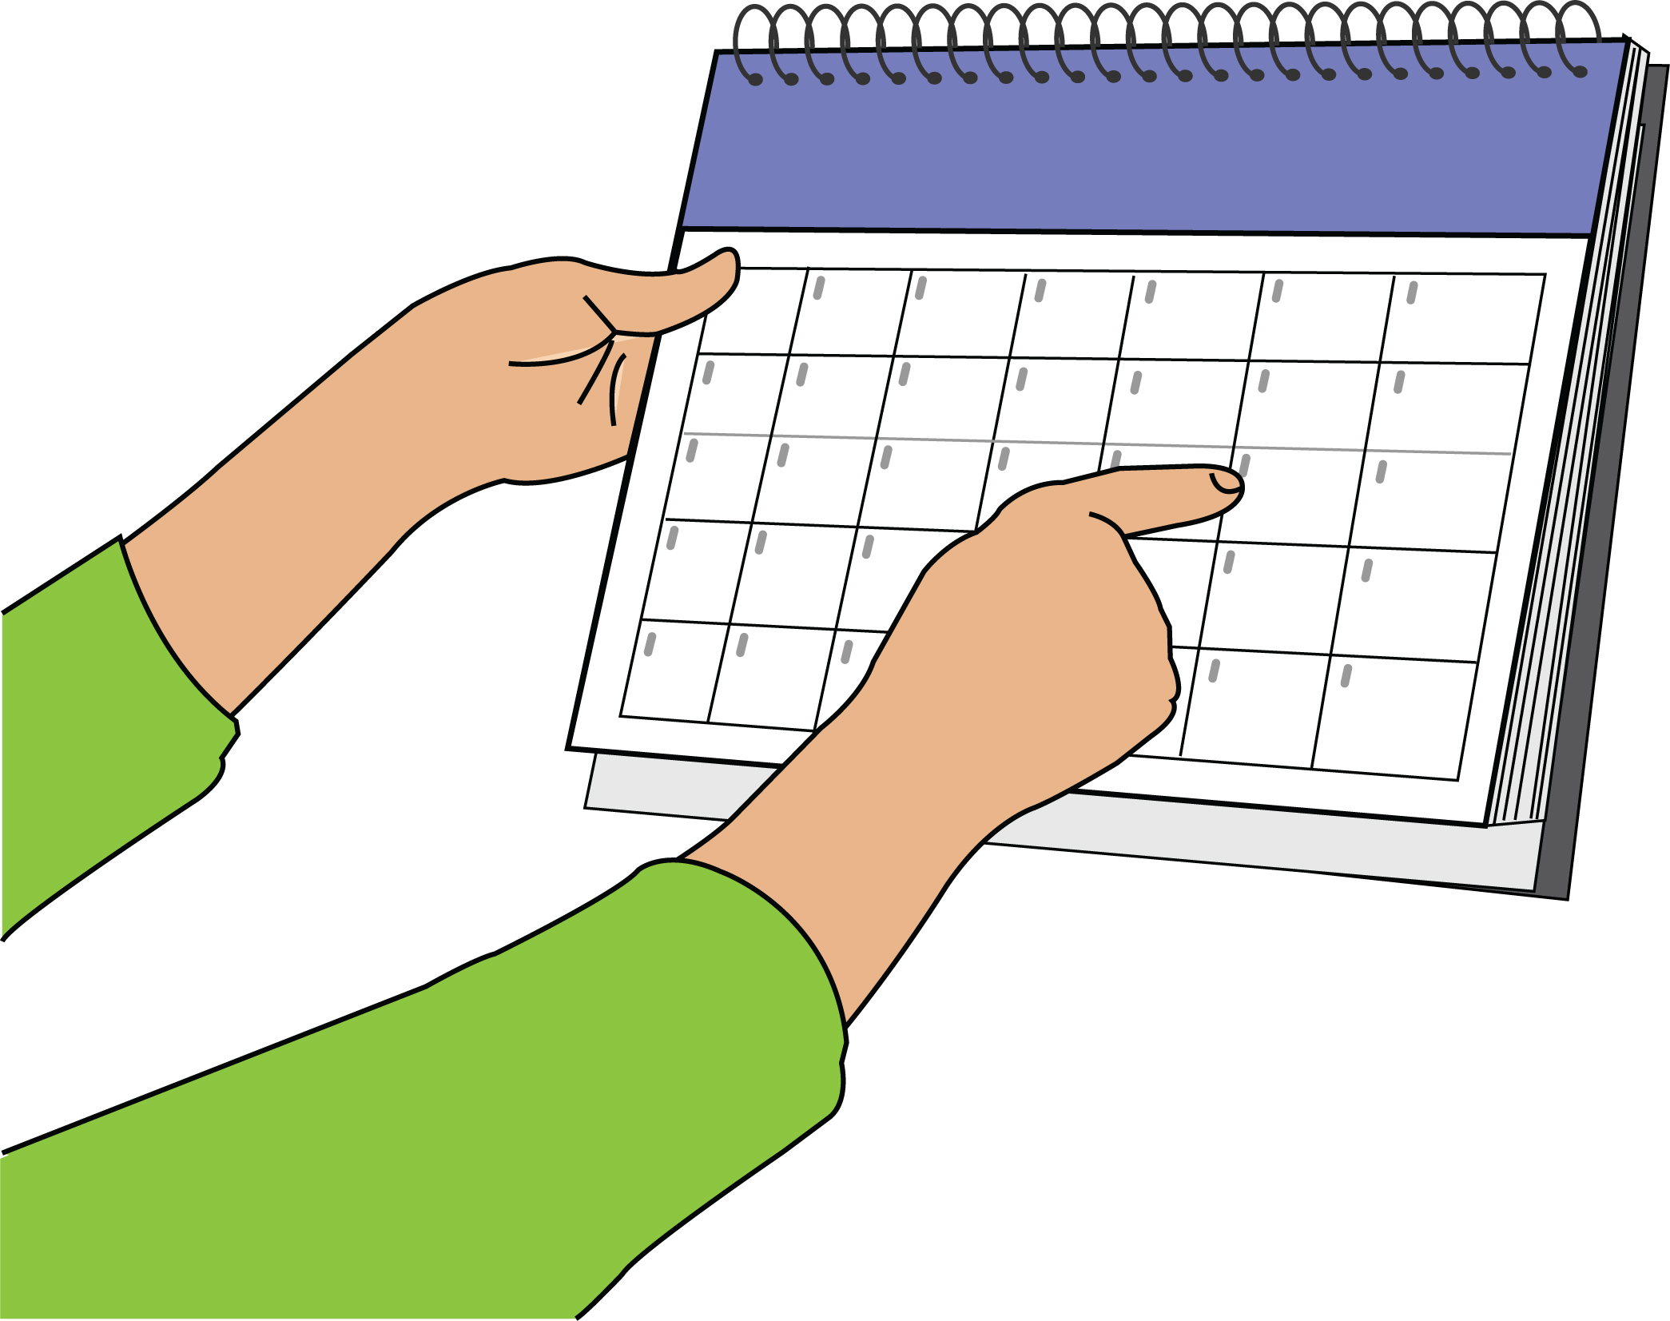

The meeting will start at 11am and finish at 4:30pm. The meeting will be held at Hamilton House, Mabledon Place, WC1H 9BD.

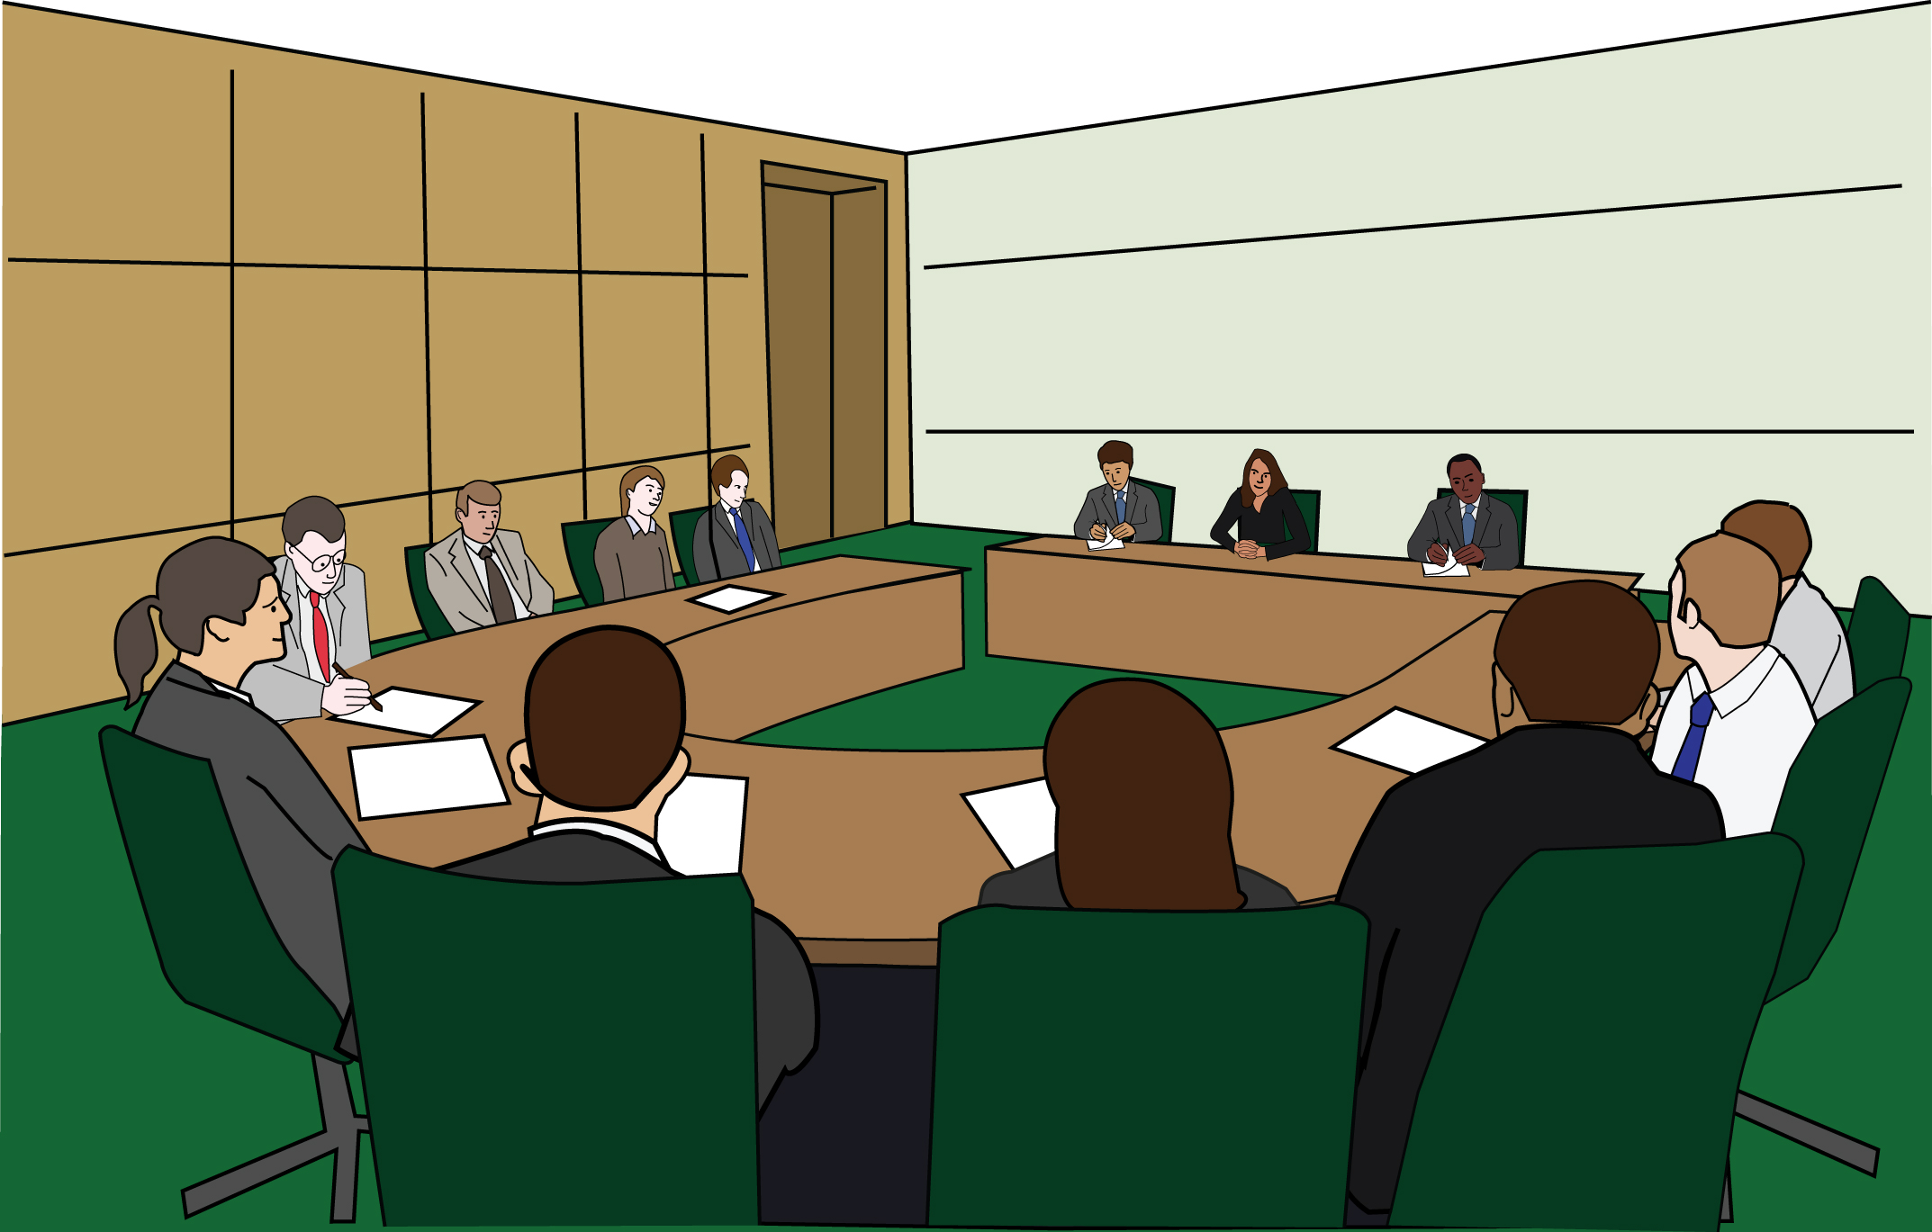
Since there was a new government in 2010, Disabled people have been treated very badly.

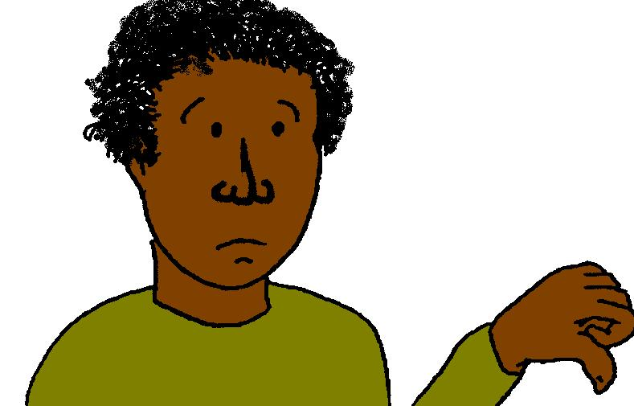
The United Nations disability committee said that there are more worried about what is happening to Disabled people in the UK than any other country at the moment.

The politicians who run our country have not listened to the United Nations disability committee. They think the changes they are making to the benefits system are going fine. They are wrong.

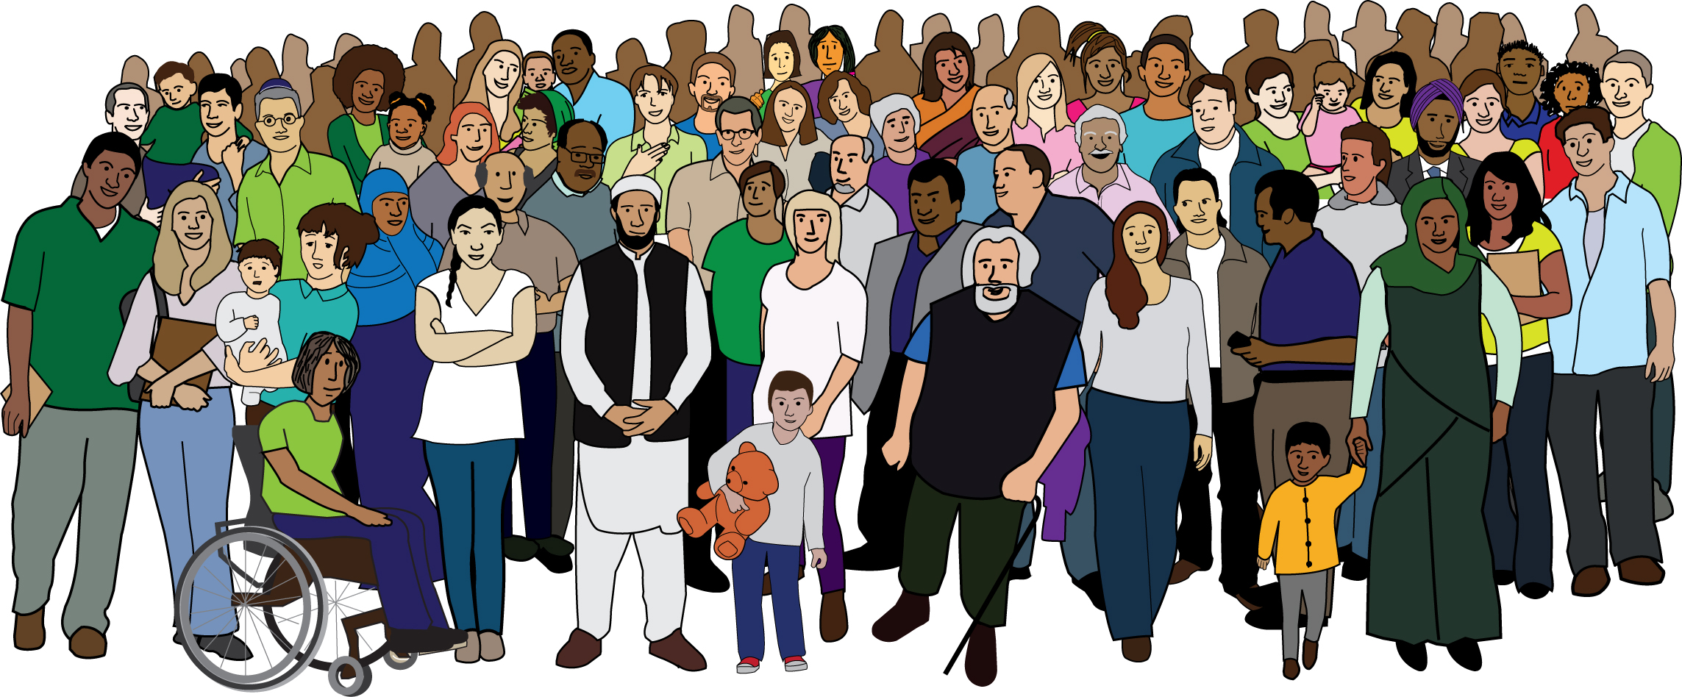
That is why we are going to have a big meeting on November 4th so that Deaf and Disabled People from different backgrounds, workplaces and communities can get together to talk about what we want to do about this.

There will be workshops on issues that are important for Deaf and Disabled people. You can pick one workshop for the first session from this list:

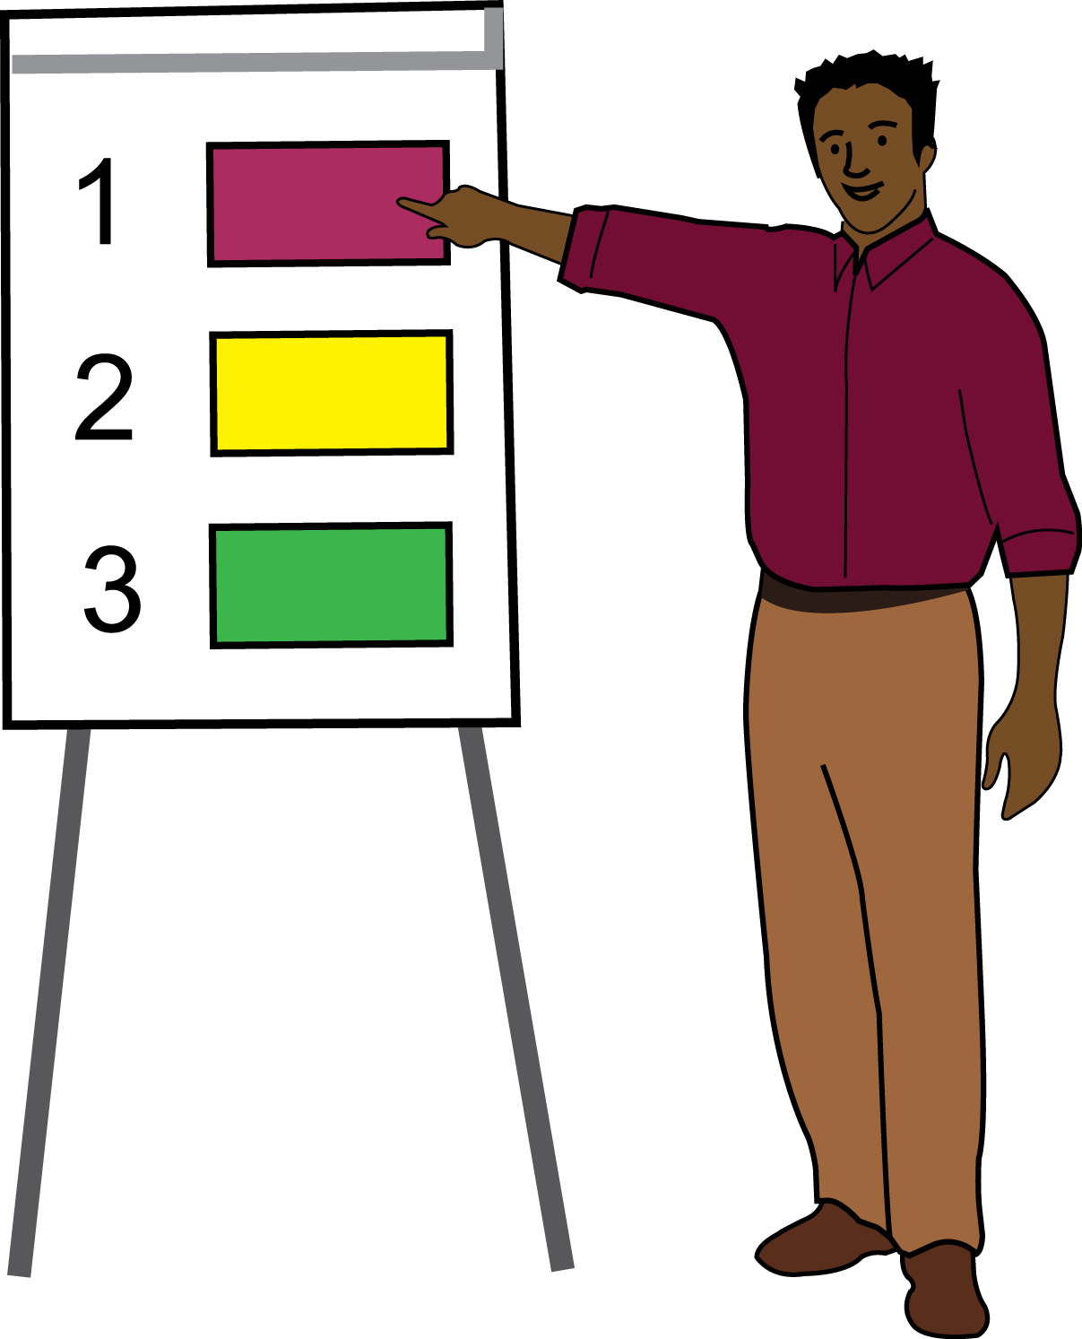

- Independent Living and social
care
- Social security (benefits)
- Accessible transport
- Inclusive education
- Mental health services
- Employment

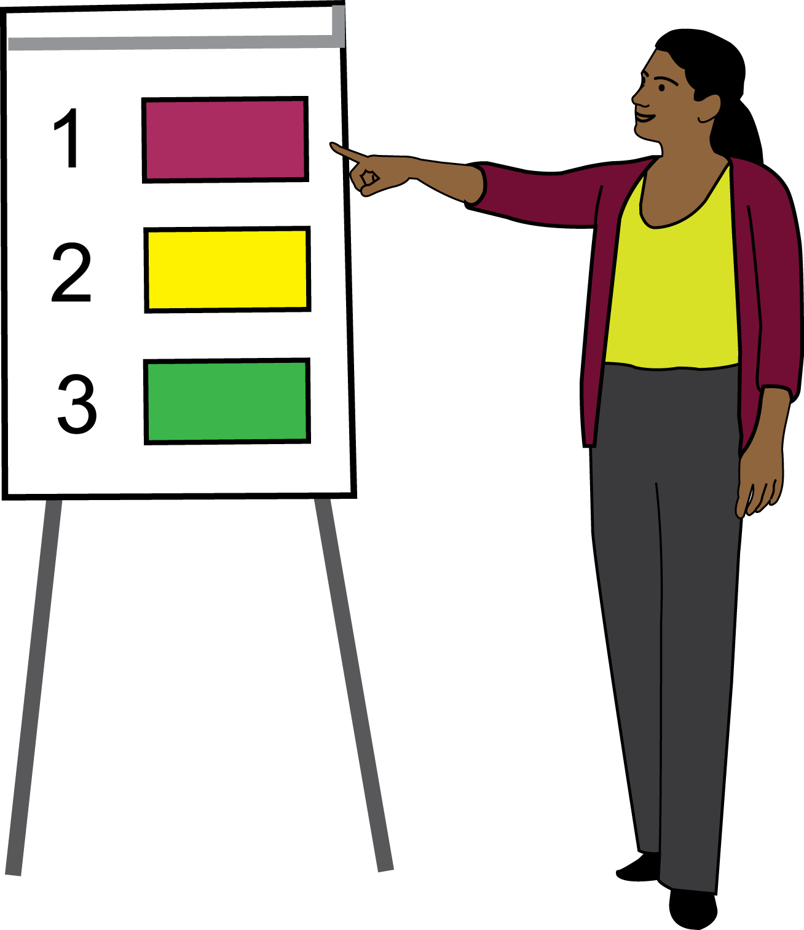
You can also pick another workshop for the second session from this list:

- Protest and direct action
- Legal challenges/ using the law
- Art and protest
- Using the media
- Intersectionality
- Trade union organising

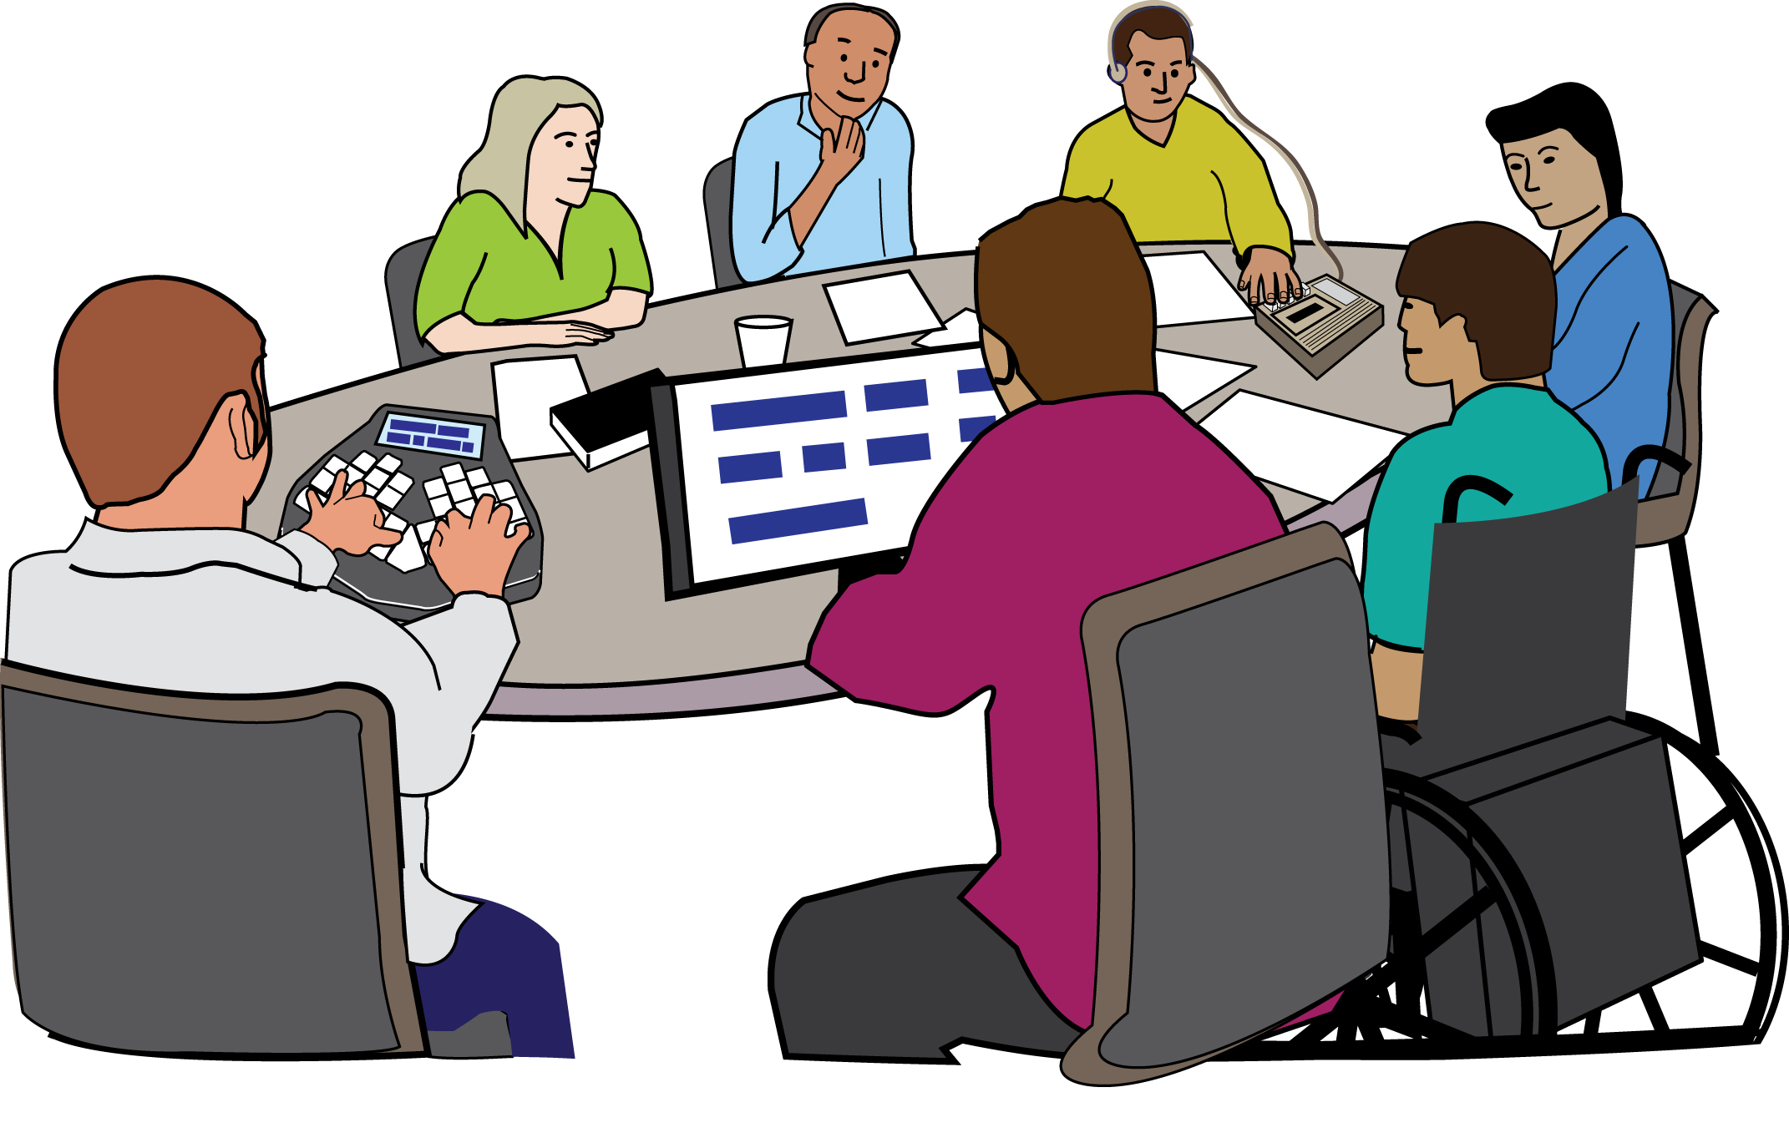
The venue of the meeting is wheelchair accessible. There will also be British Sign Language (BSL) interpreters at the meeting. Please tell us if you have any other access needs.

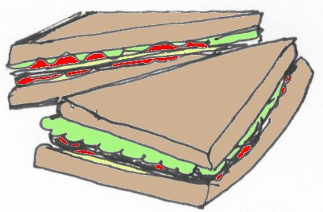

There will be a free lunch.

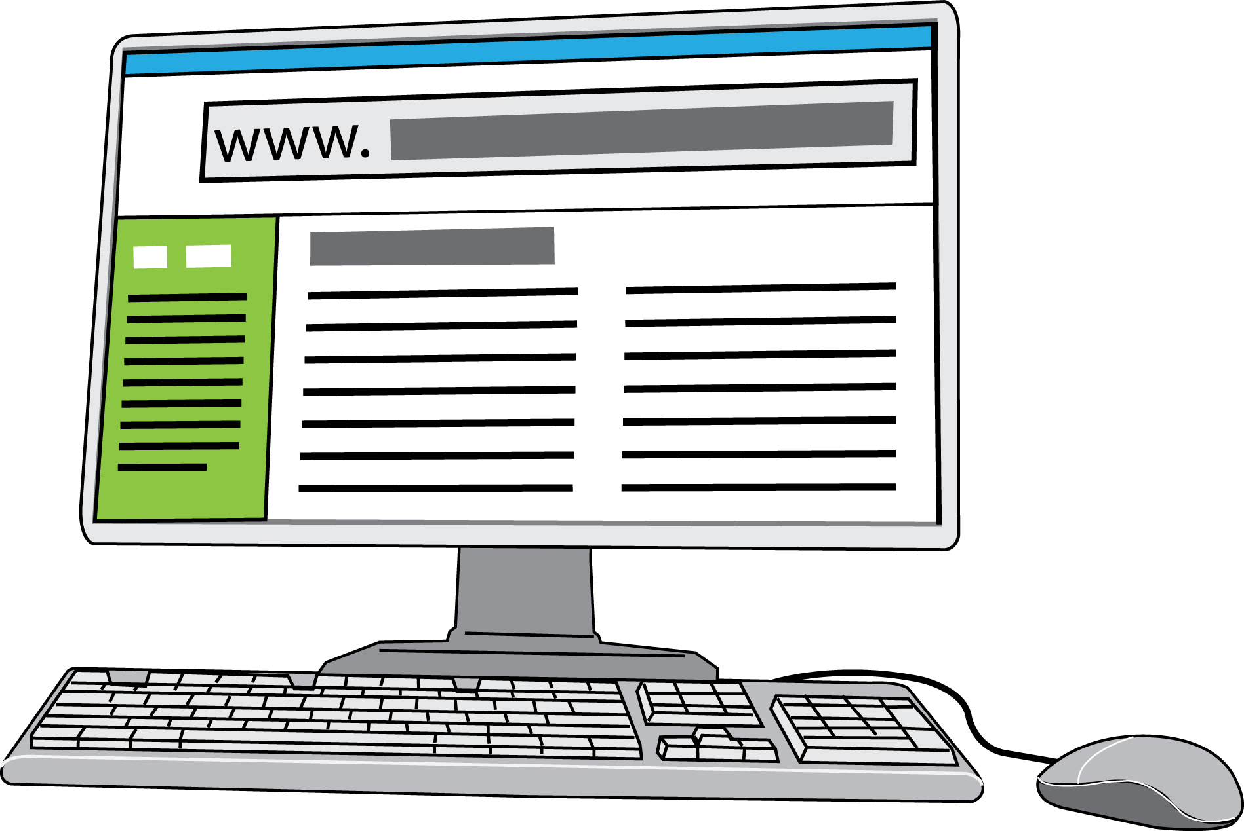

To book a place please click on this link: https://www.eventbrite.co.uk/e/national-disabled-peoples-summit-tickets-38706991654

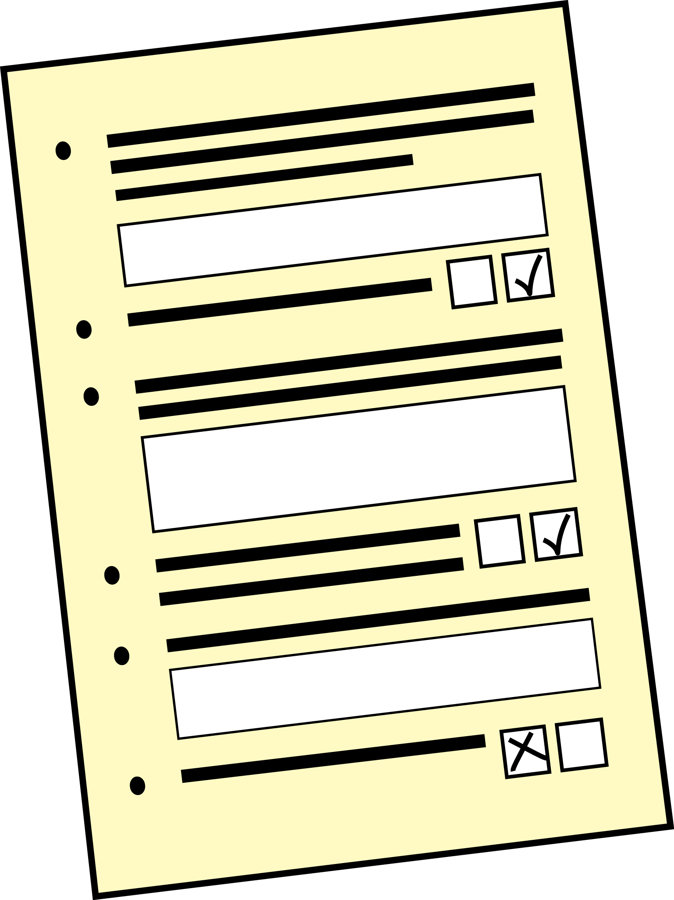
On this website, please click REGISTER and type in your name, address and email address. There will be a question asking if you have any access needs like if you are in a wheelchair or if you use BSL or have any other access needs. There will also be a question asking if you would like a vegetarian or gluten free lunch.

It is important you fill out this online form so that we can make sure everyone has a good day.

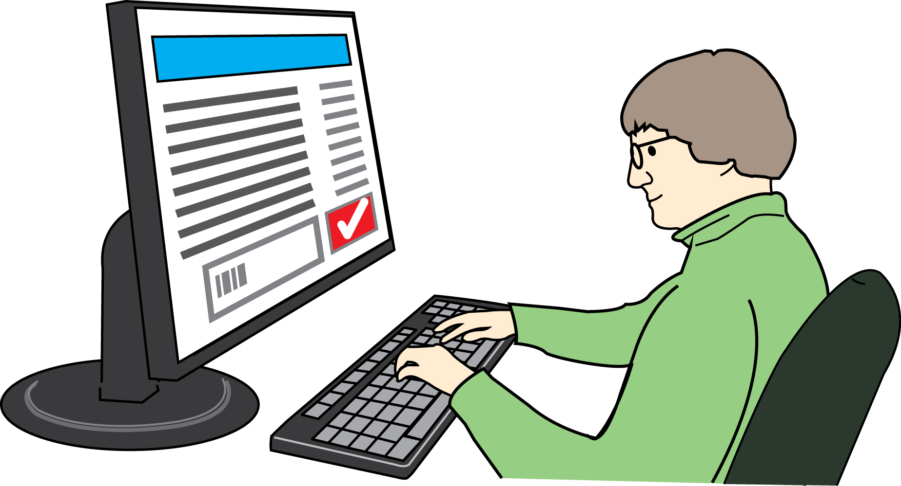
If you can’t come along to this meeting we can send you a link to watch it online.

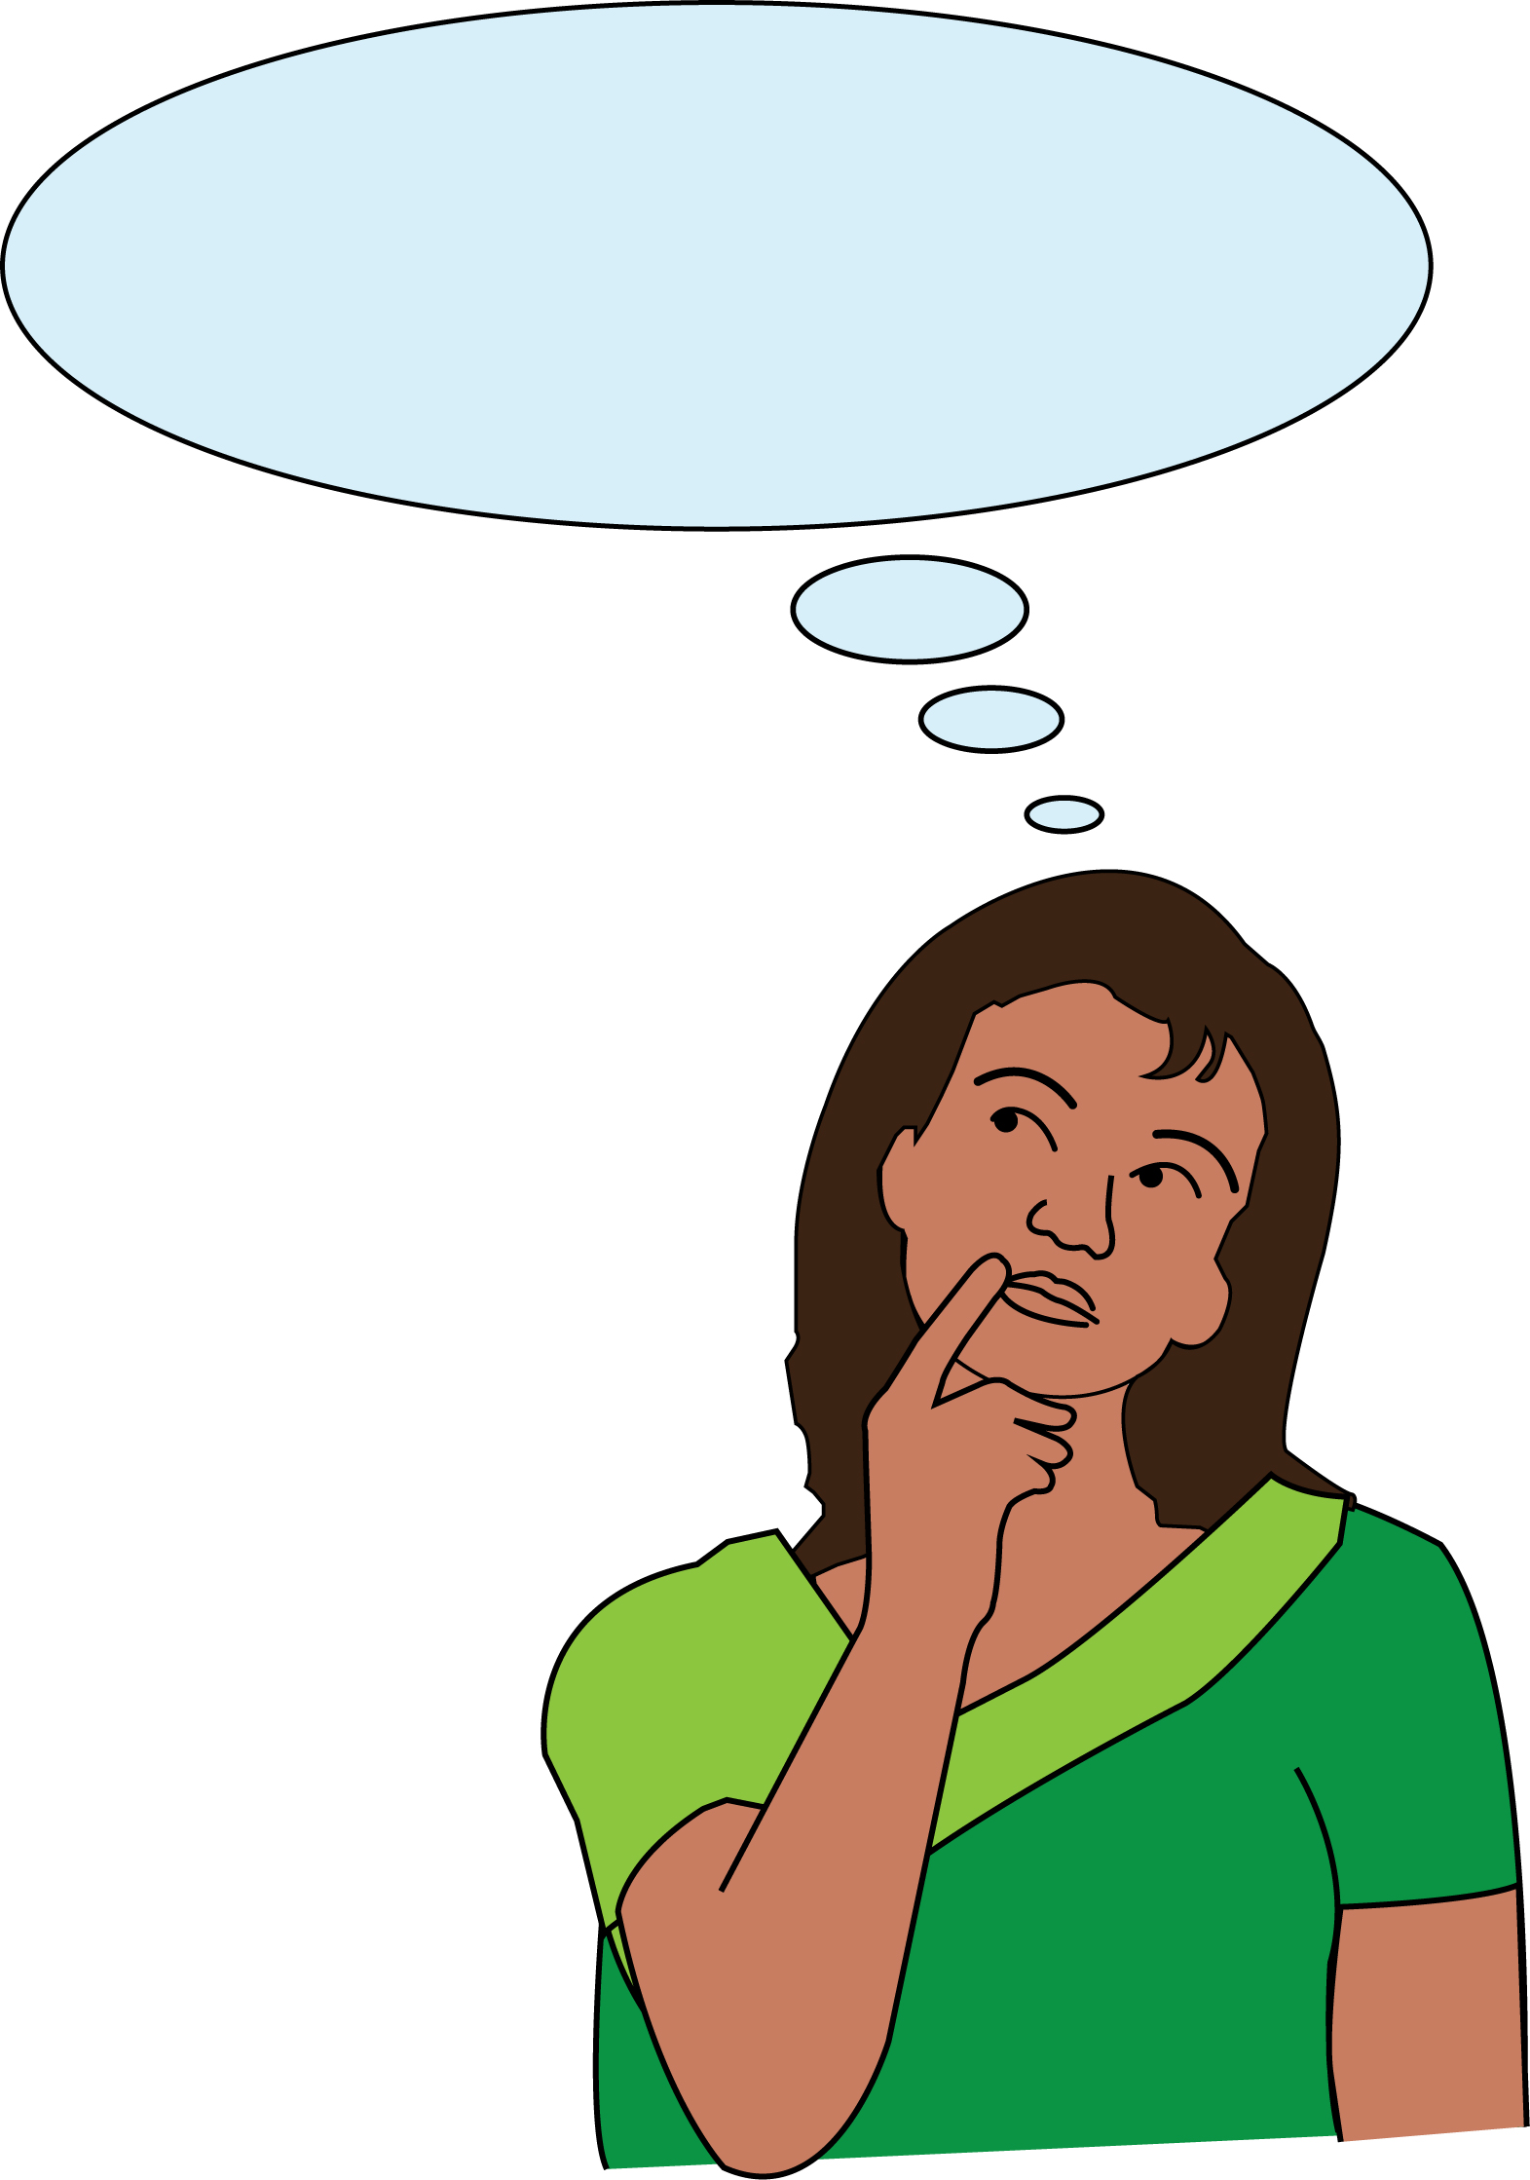

If you have any questions please email ellen.morrison@inclusionlondon.org.uk

